Java 17 Features

JEP:Pattern Matching for switch

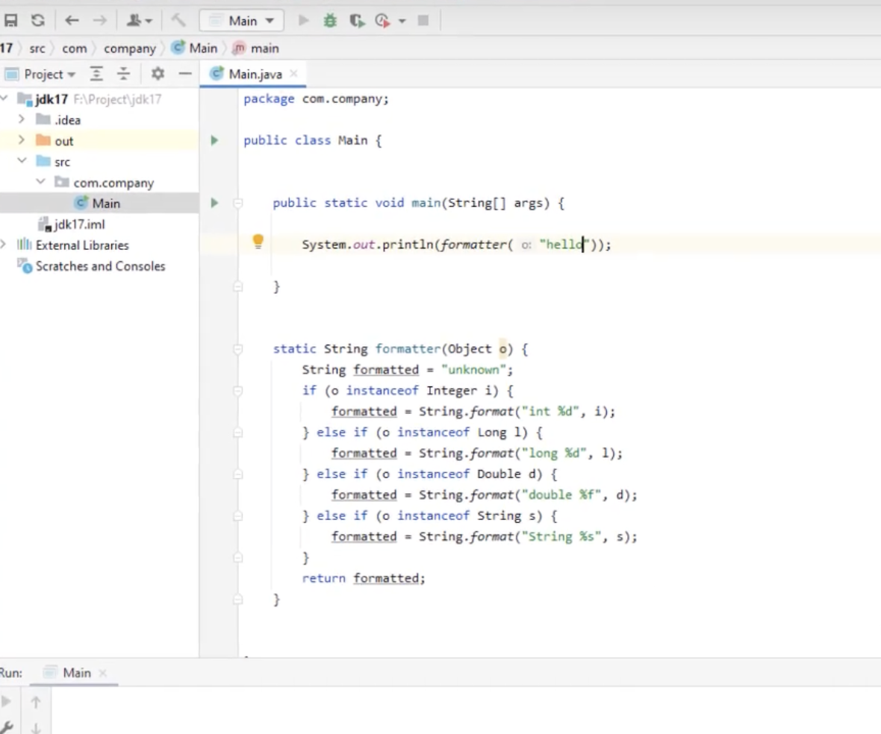

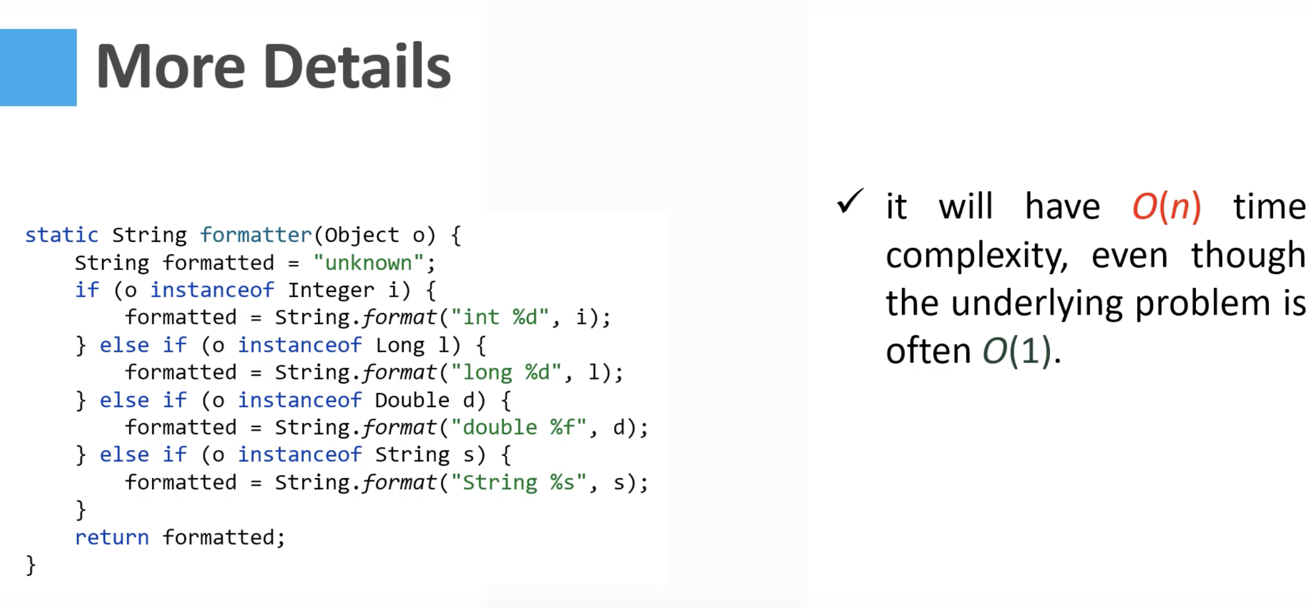

Solution is

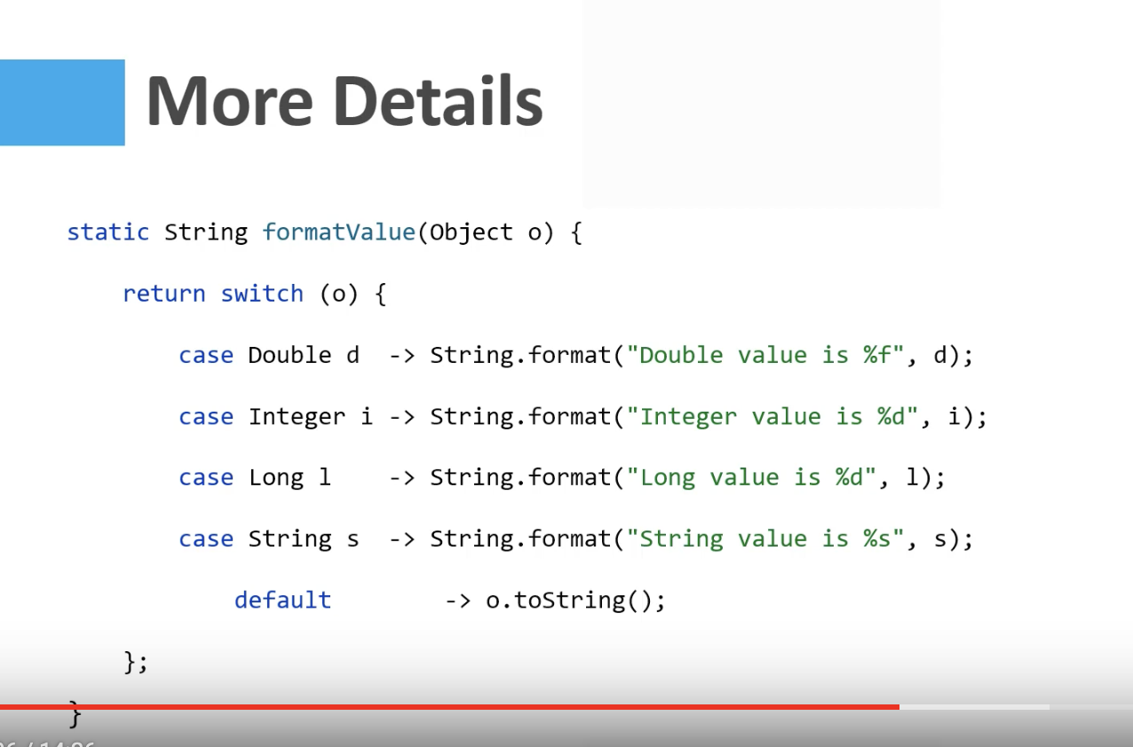

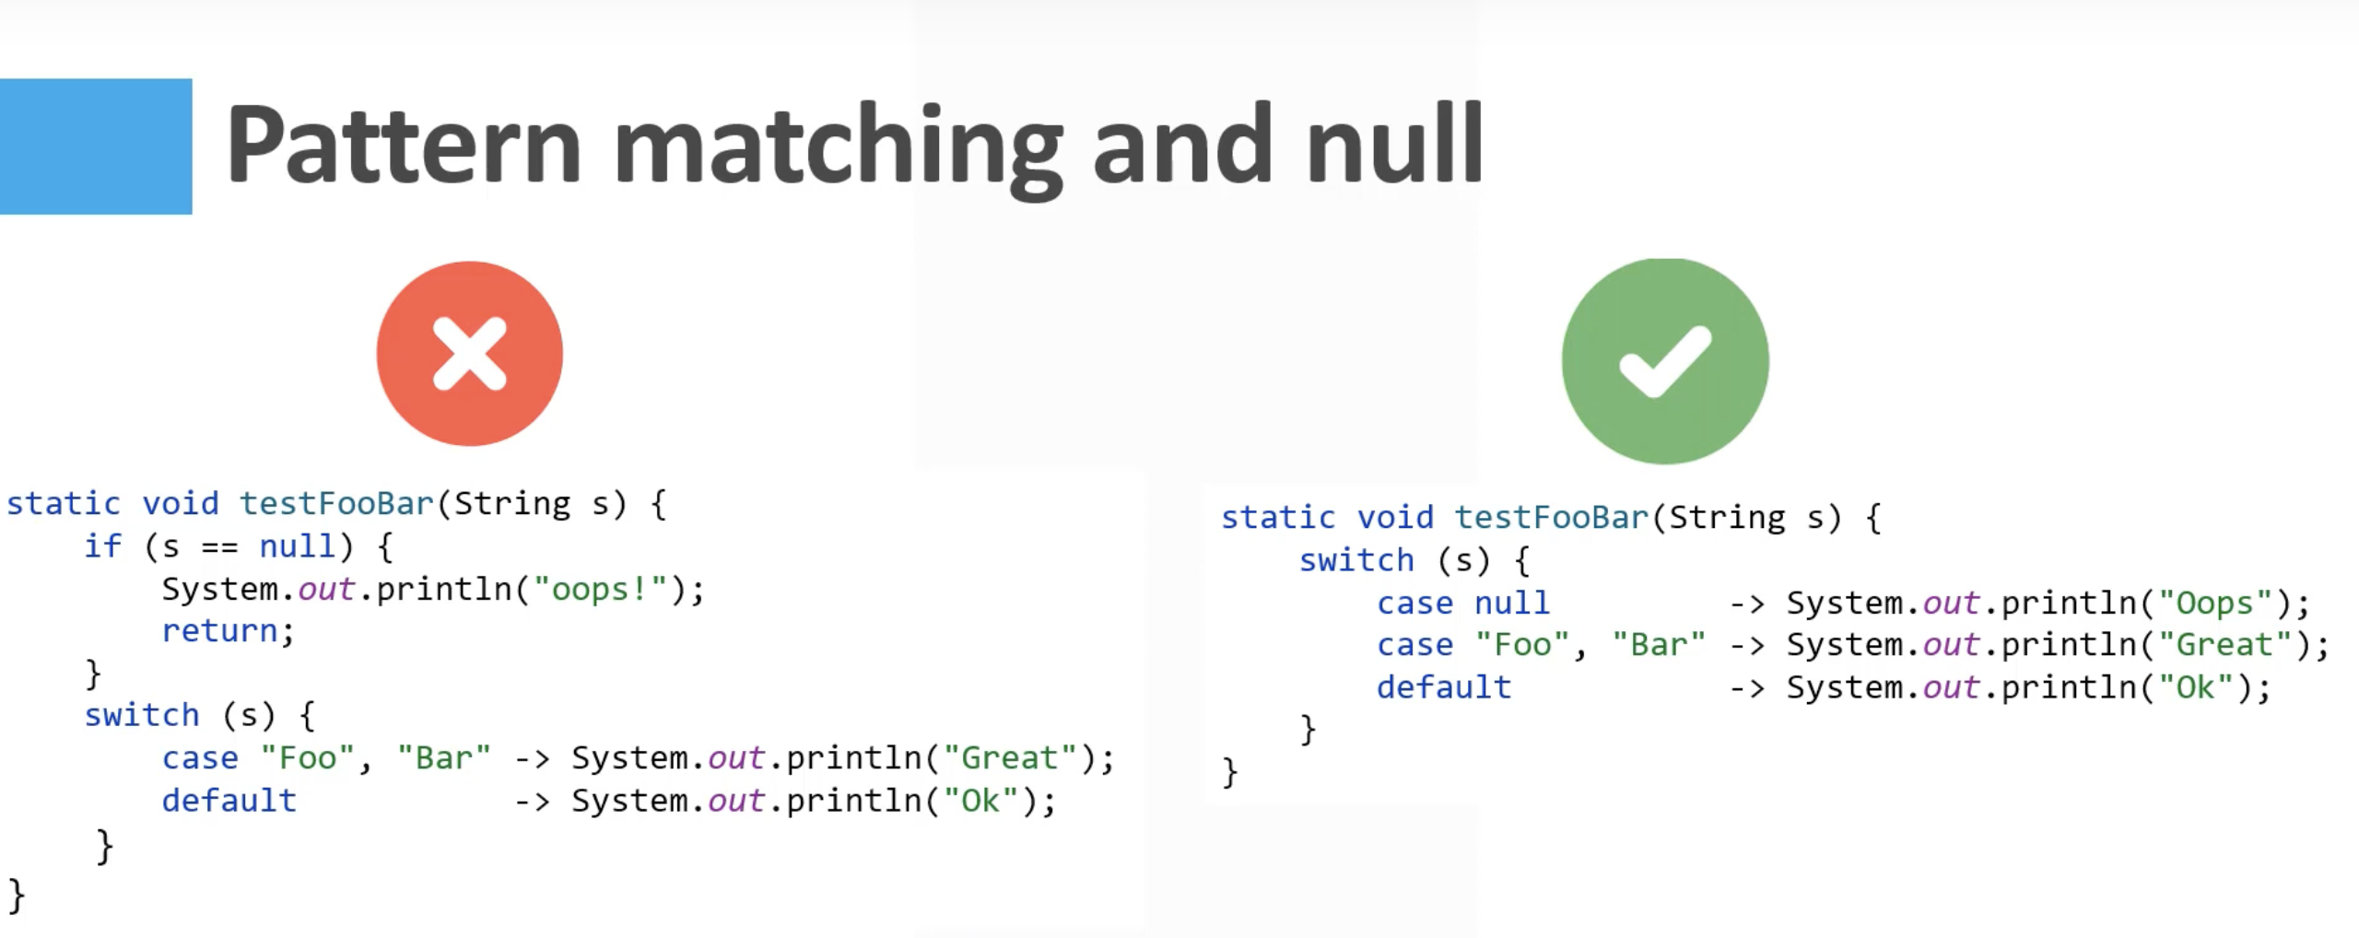

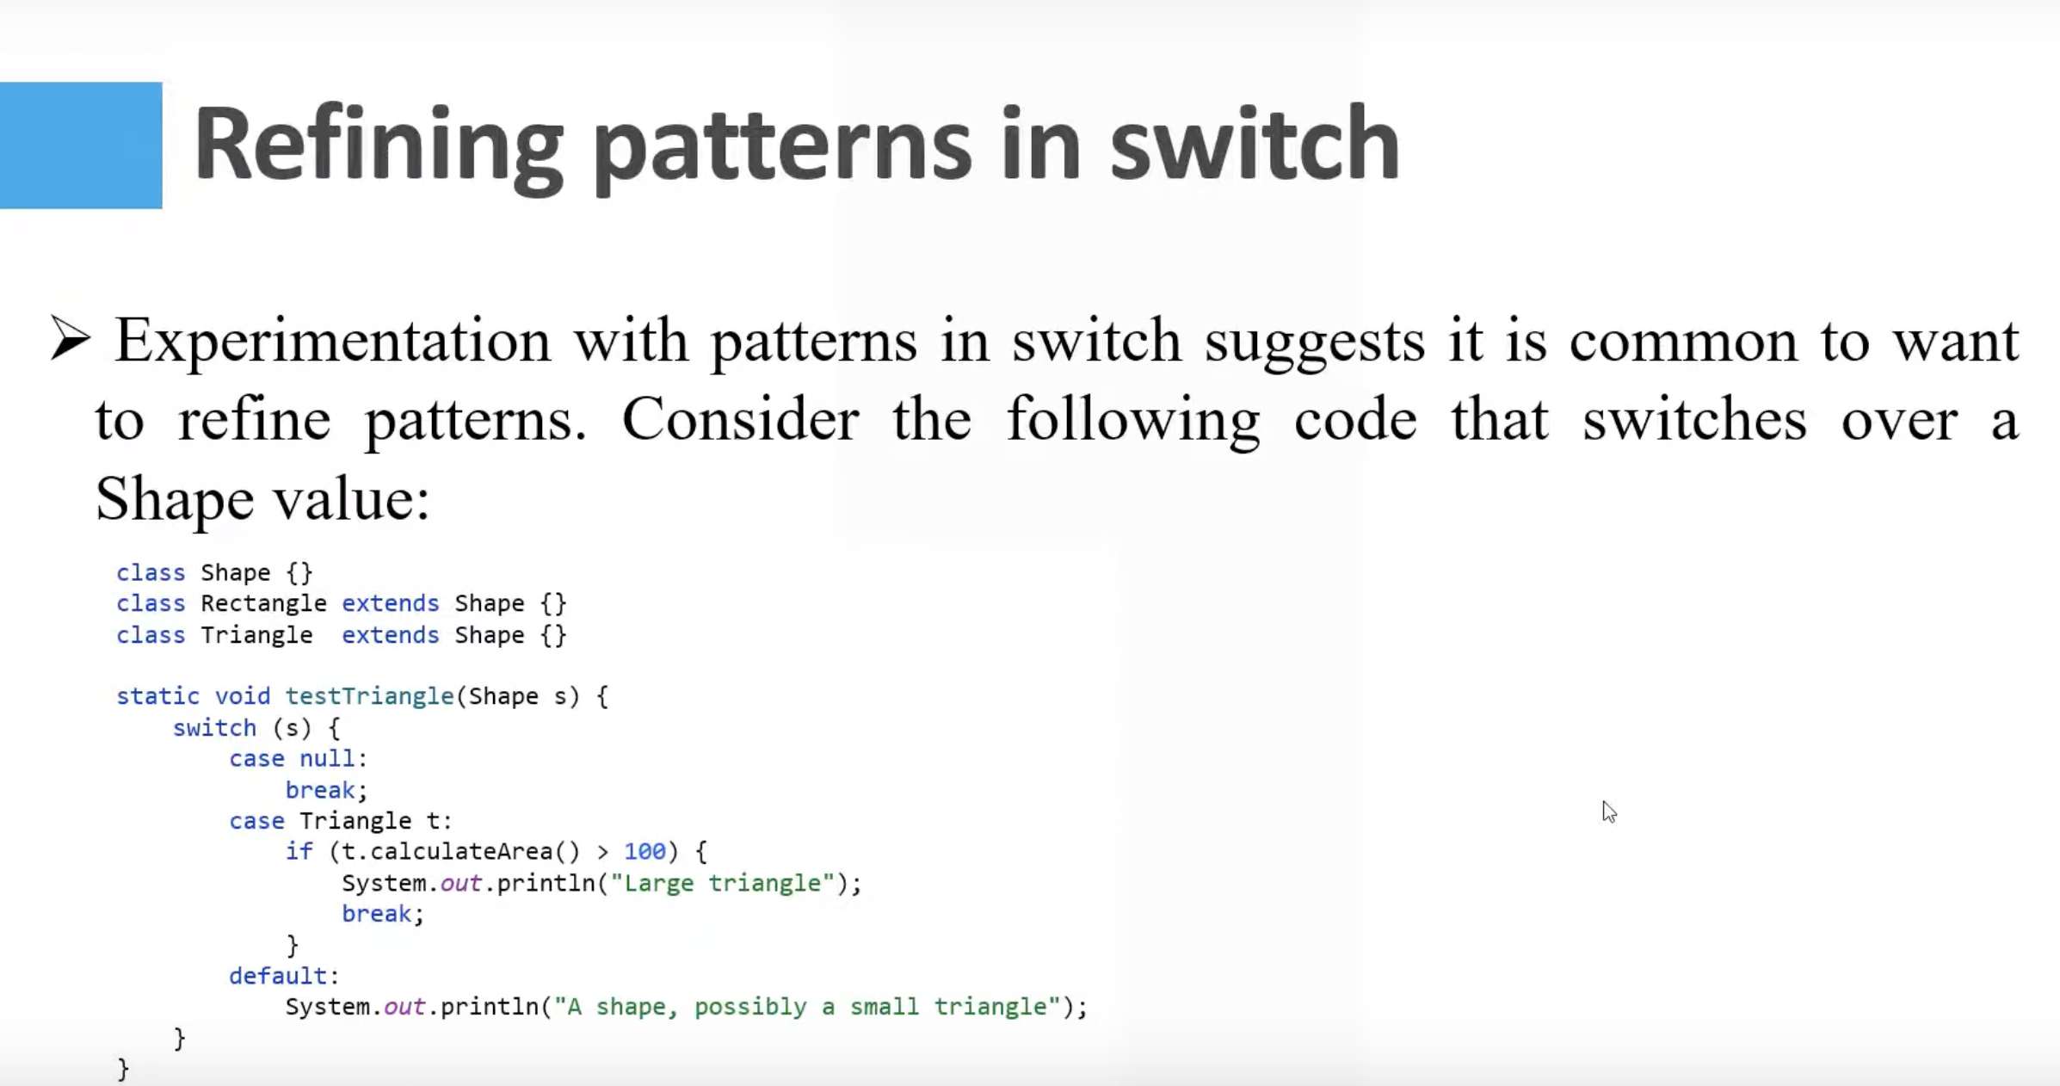

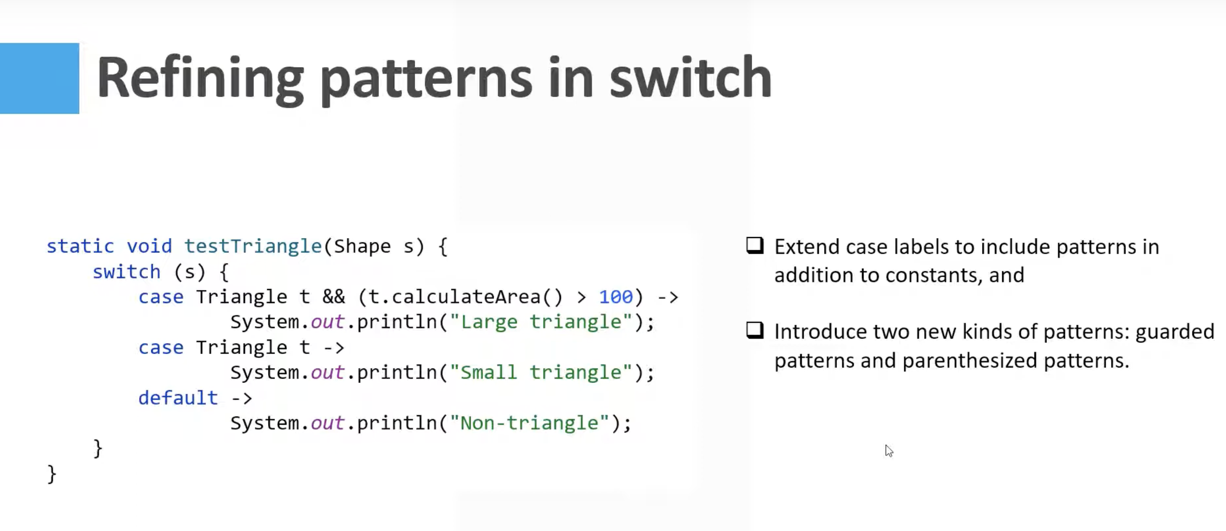

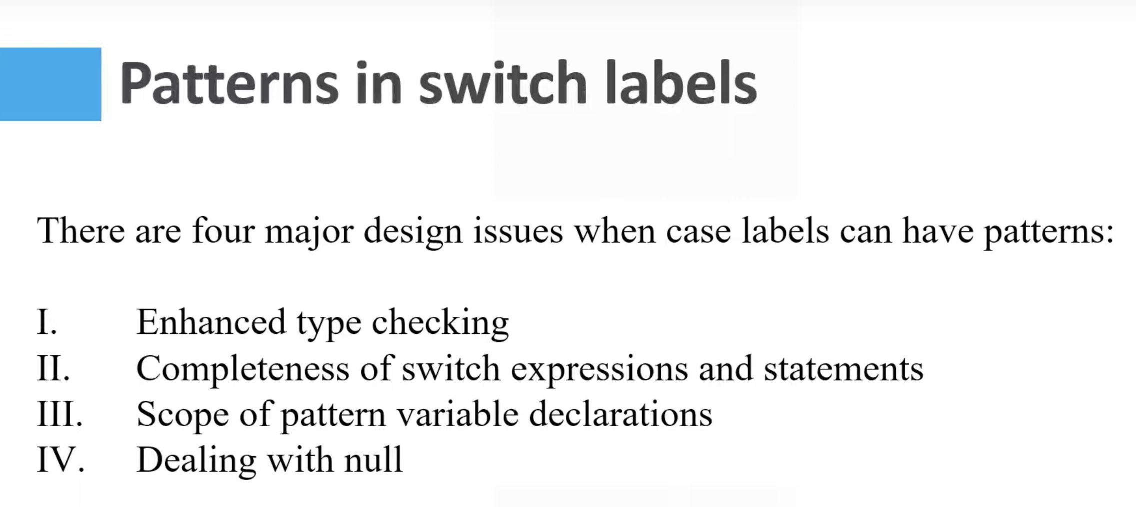

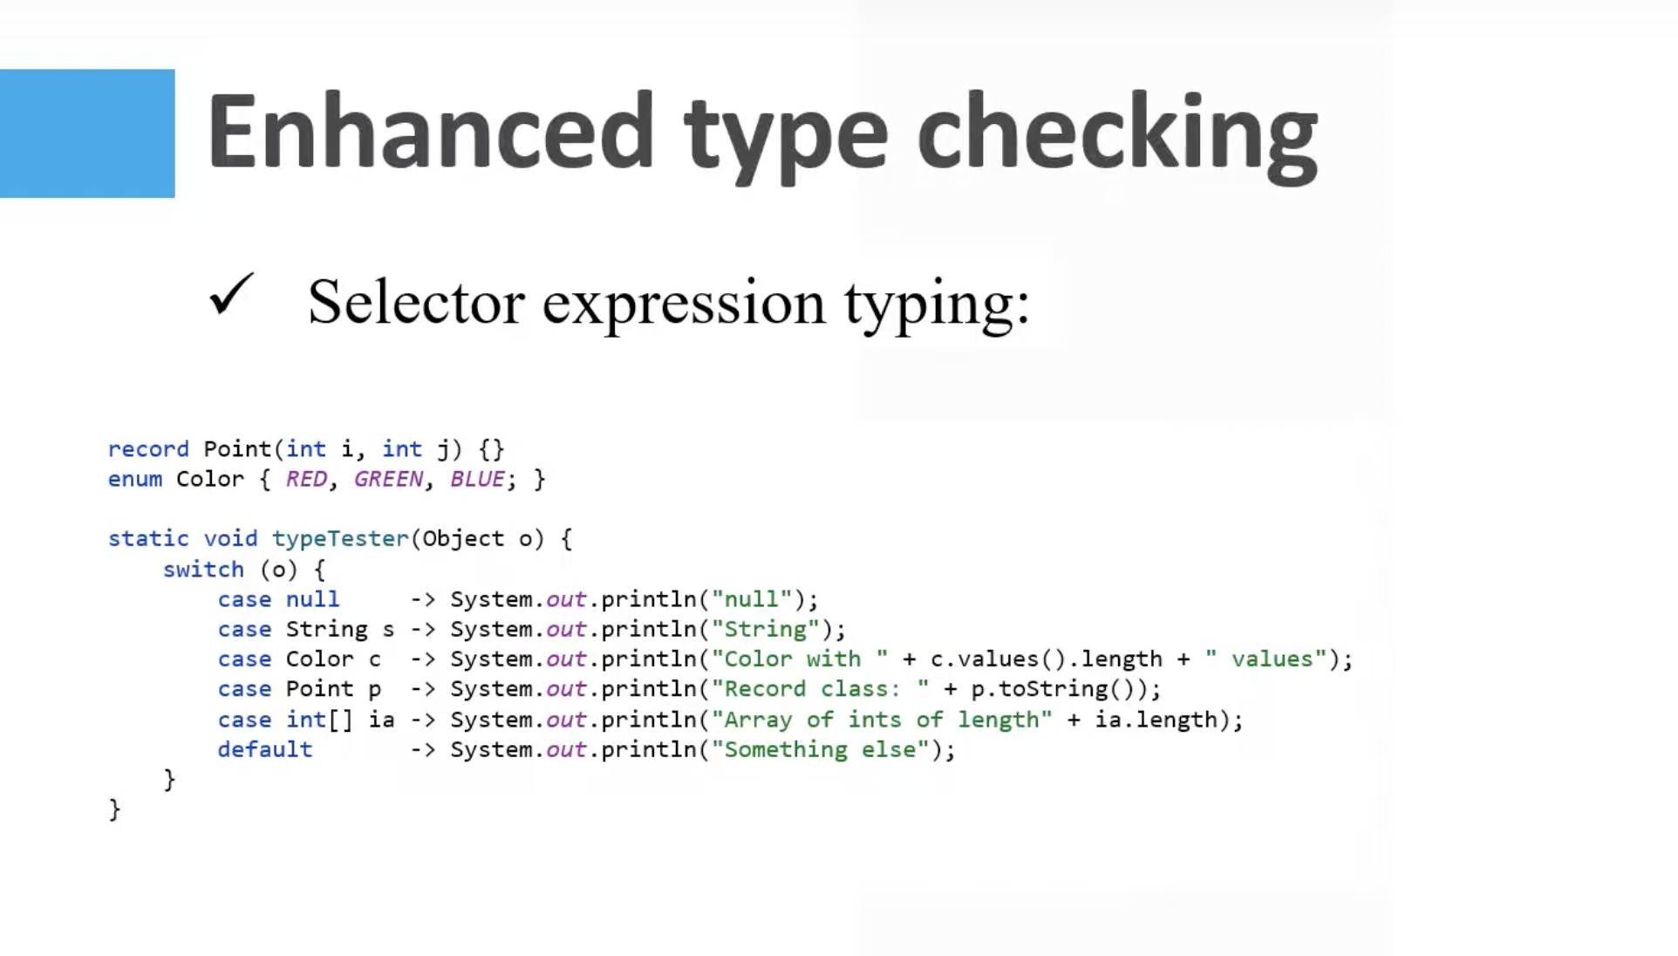

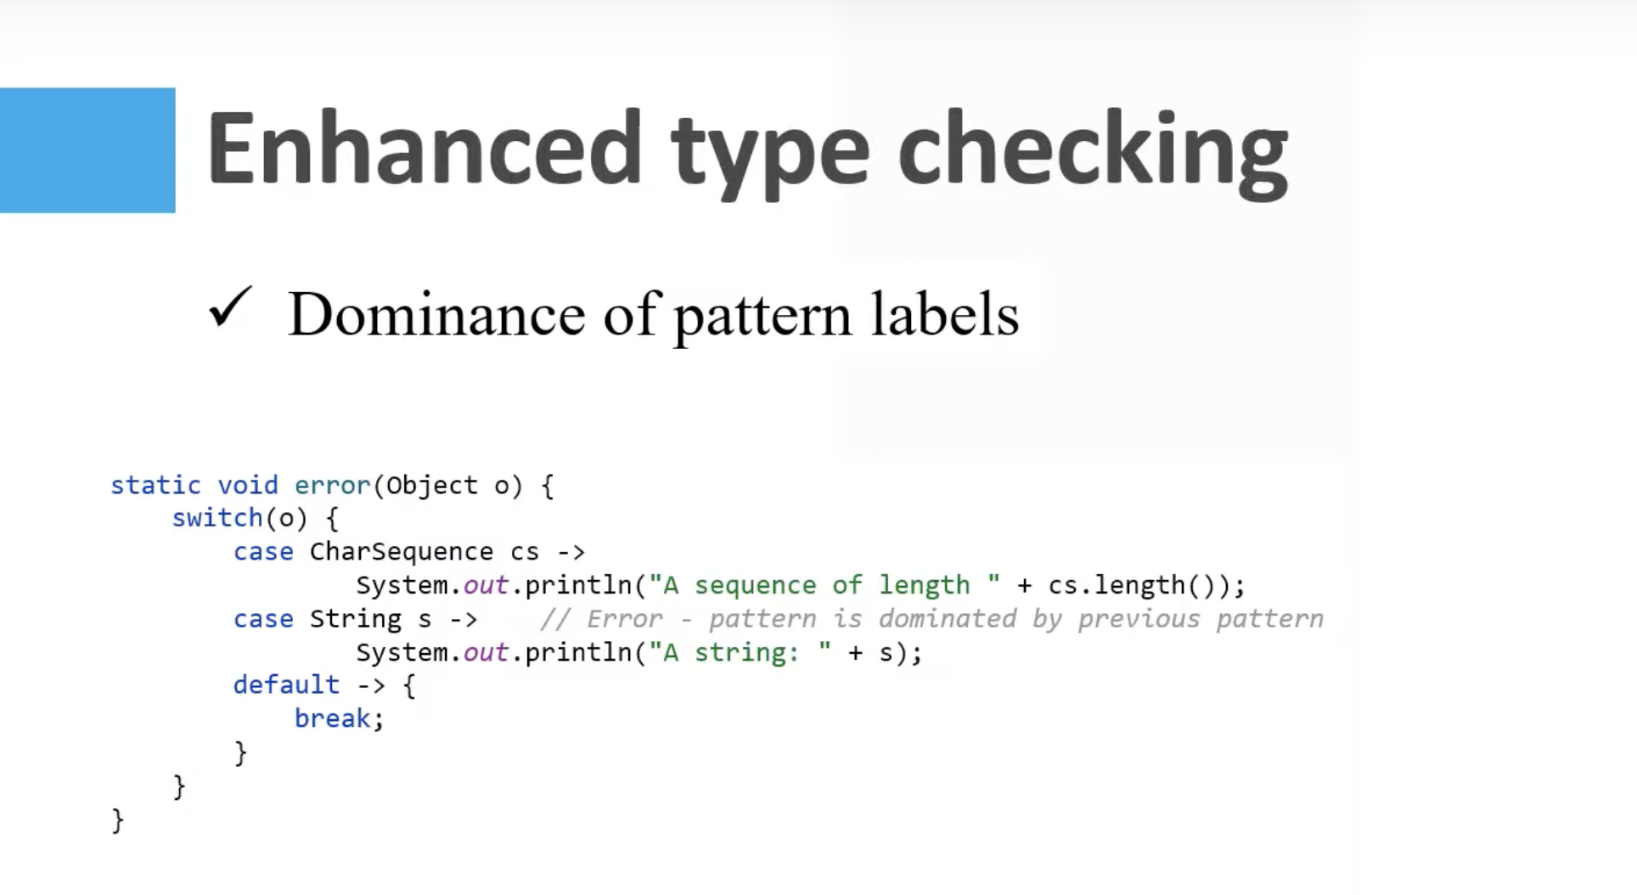

Compilet throws error as sequence is dominated by previous spattern



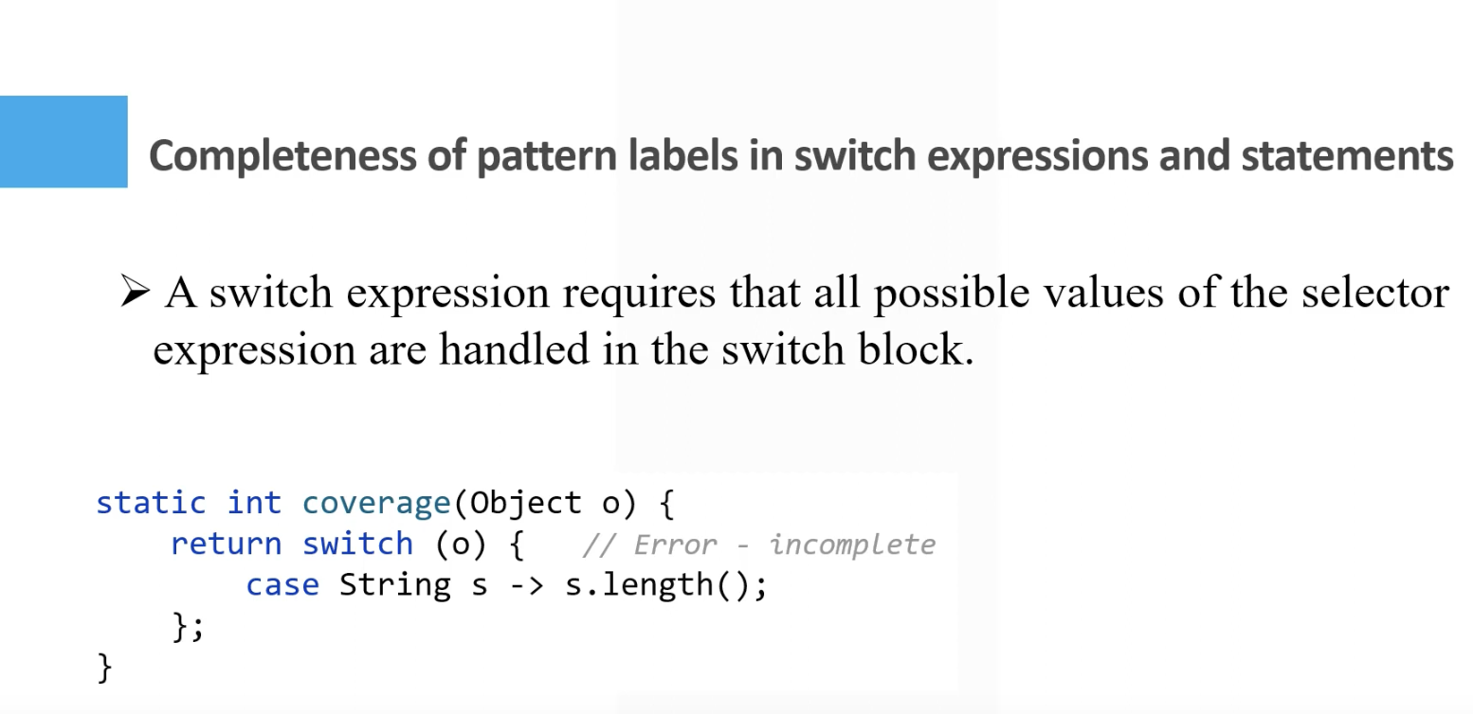

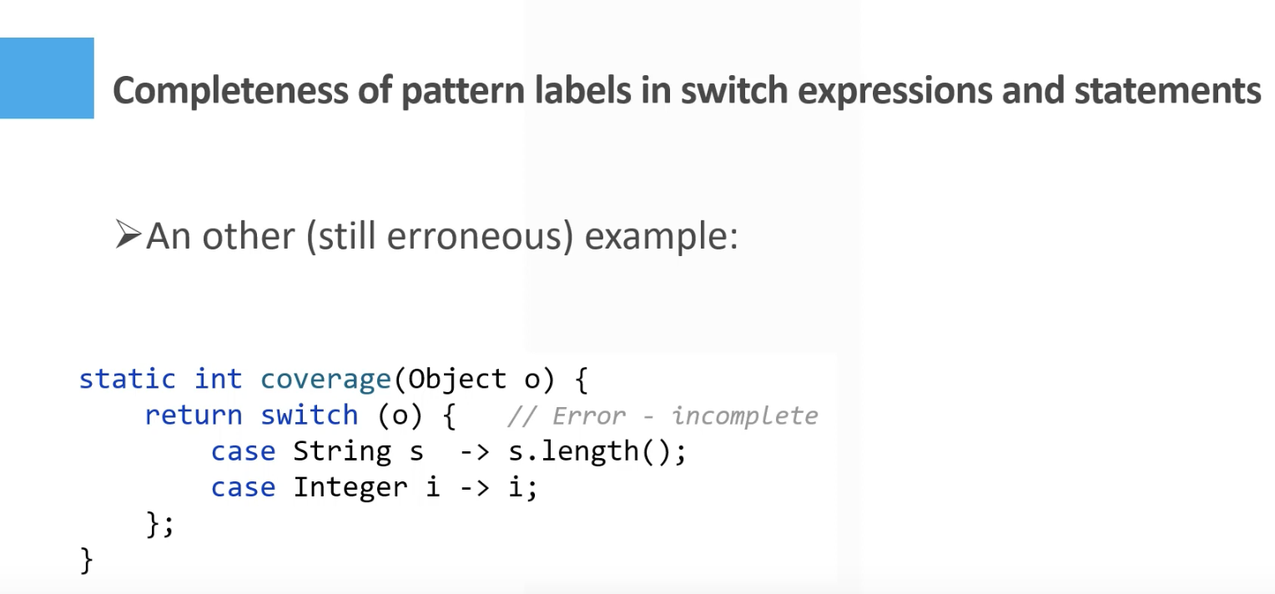

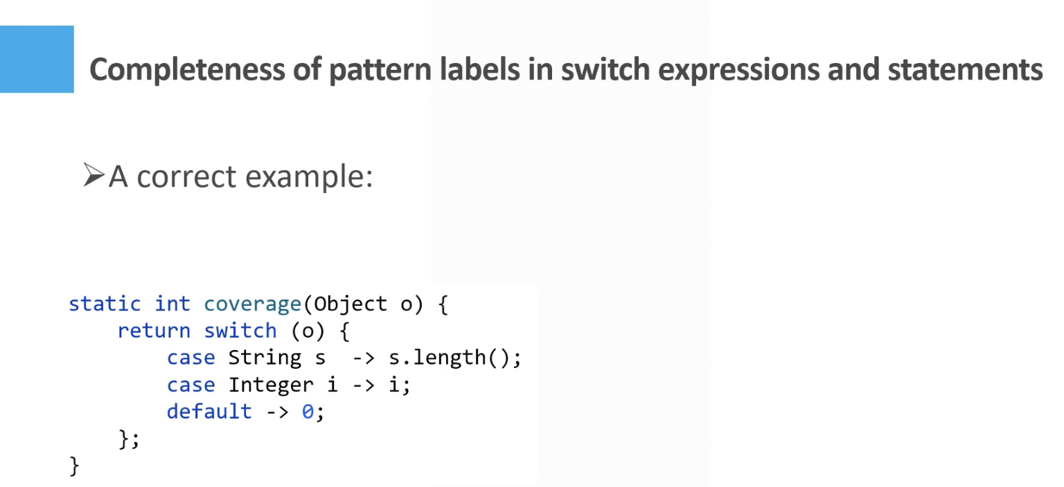

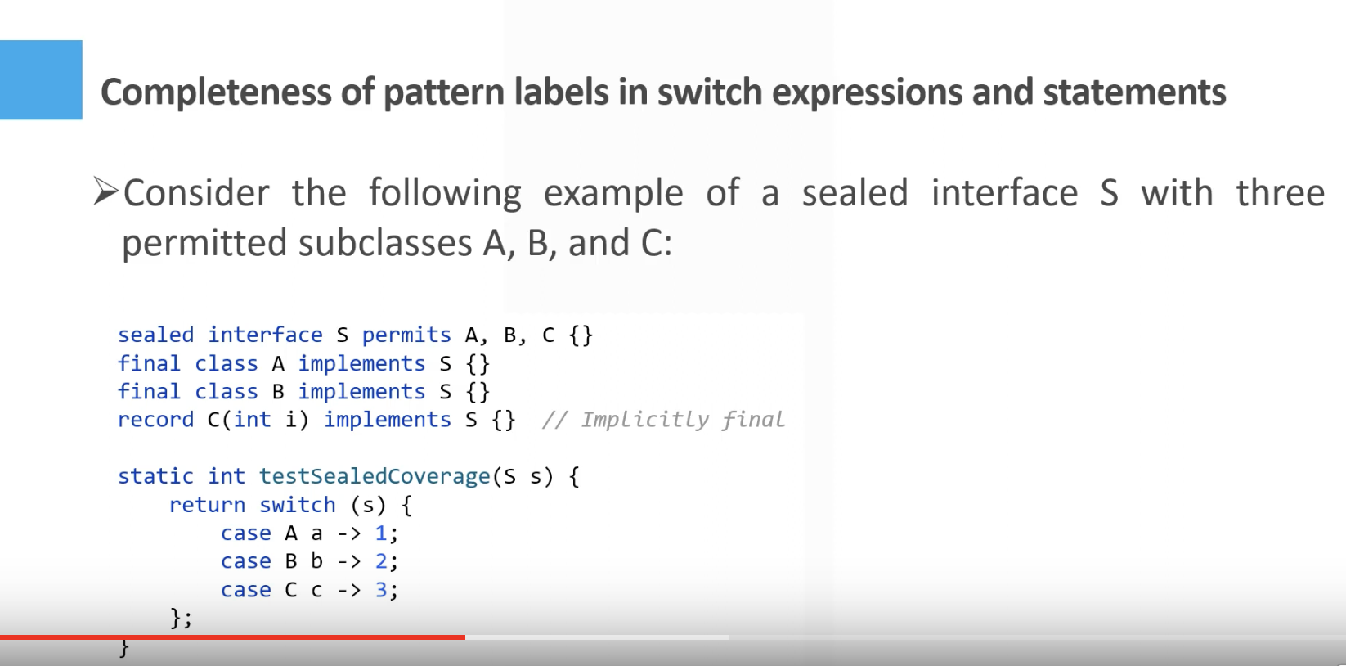

COmpilet adds label IcnaptbleClassChangeErronin case when sealed calss is changed and switch case isn’t update d

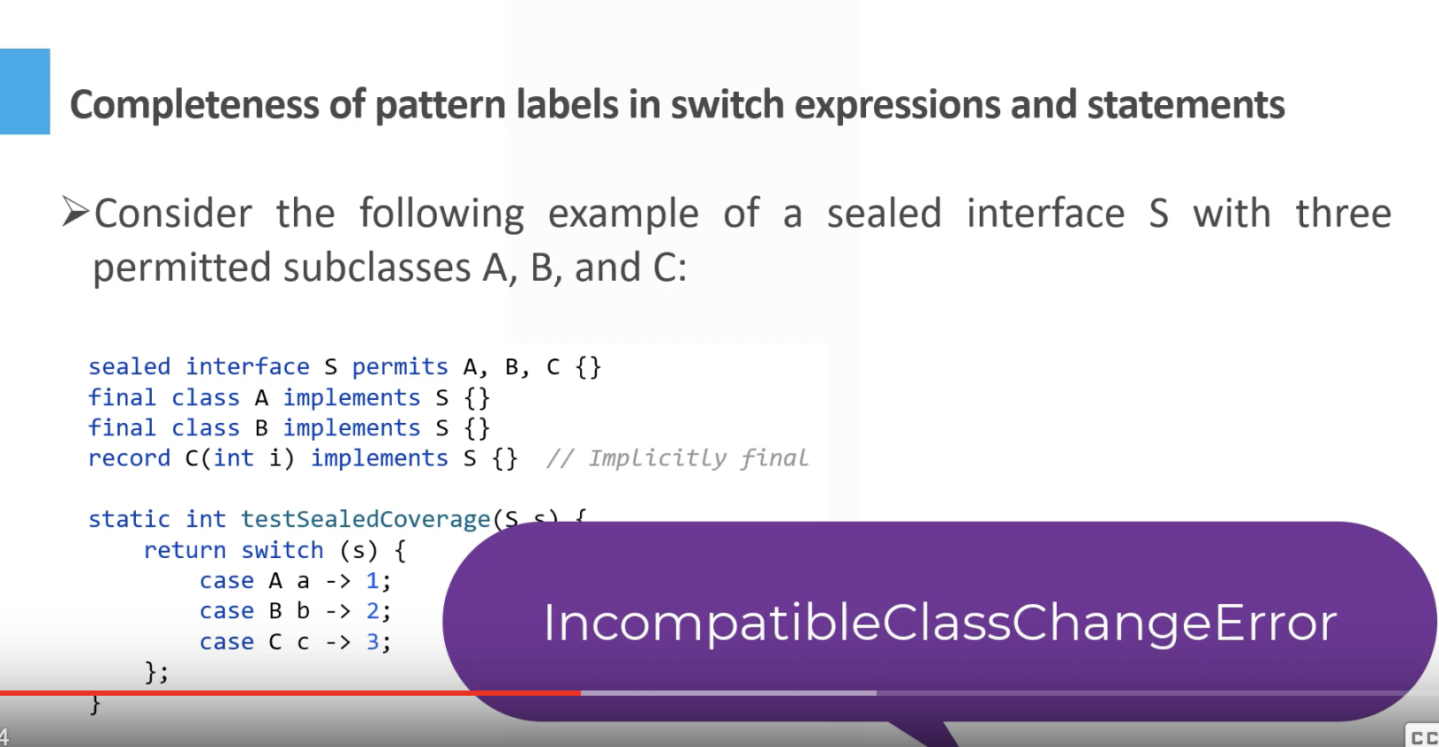

If switch case doenst impolemnt all labels then compiler will throw eror

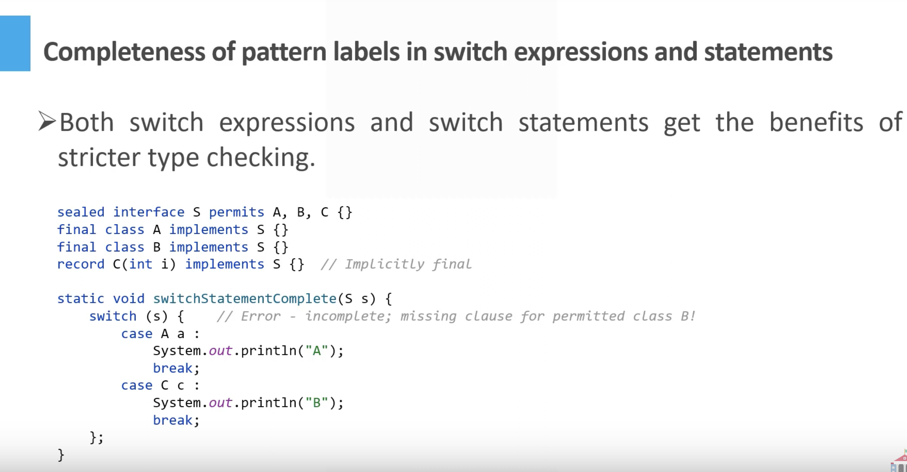

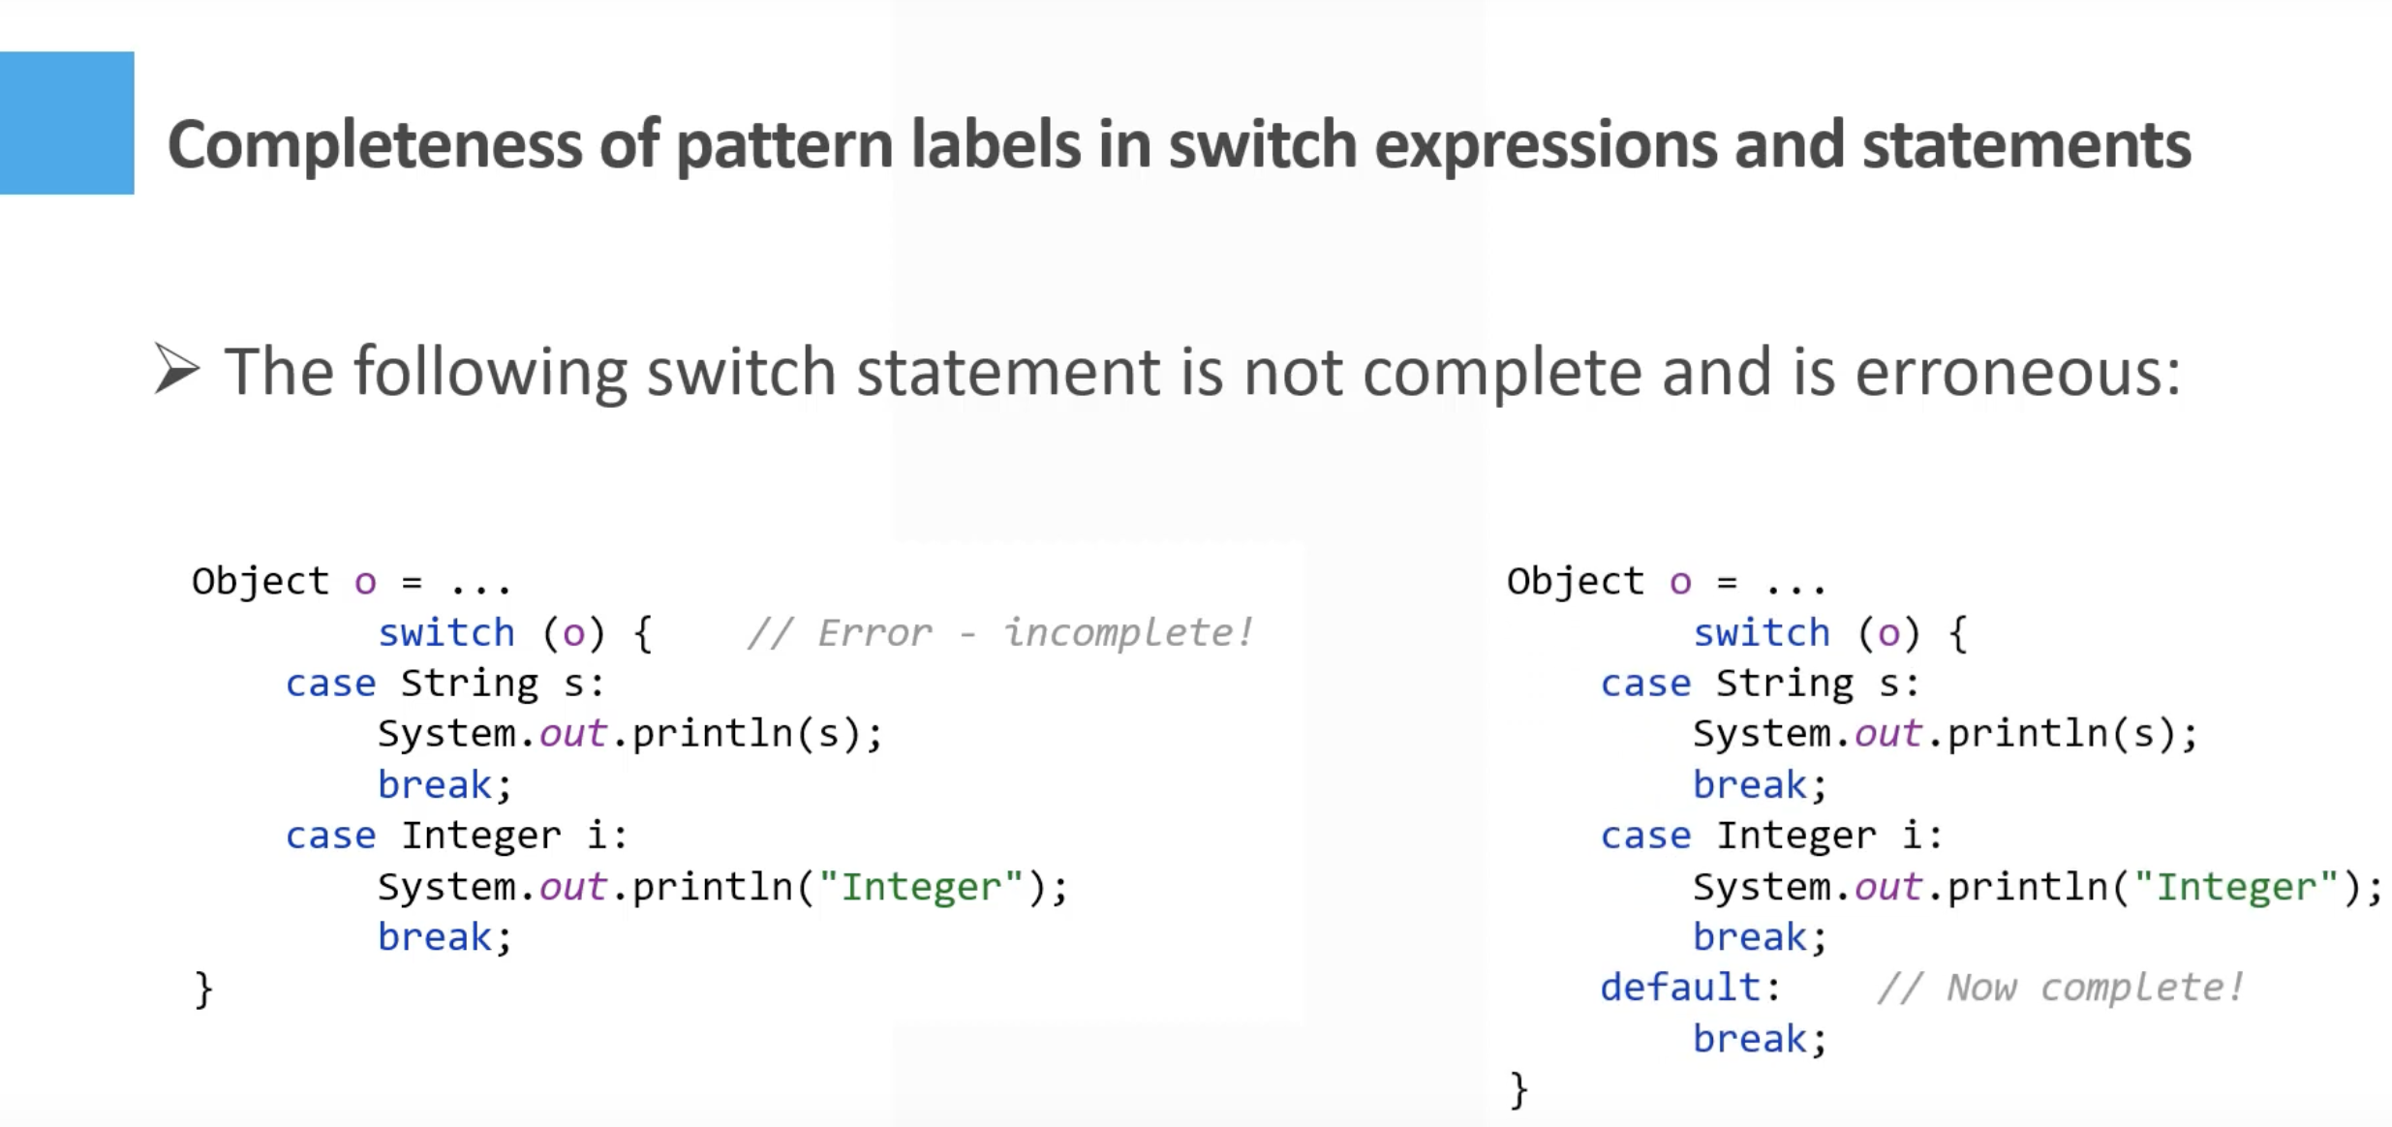



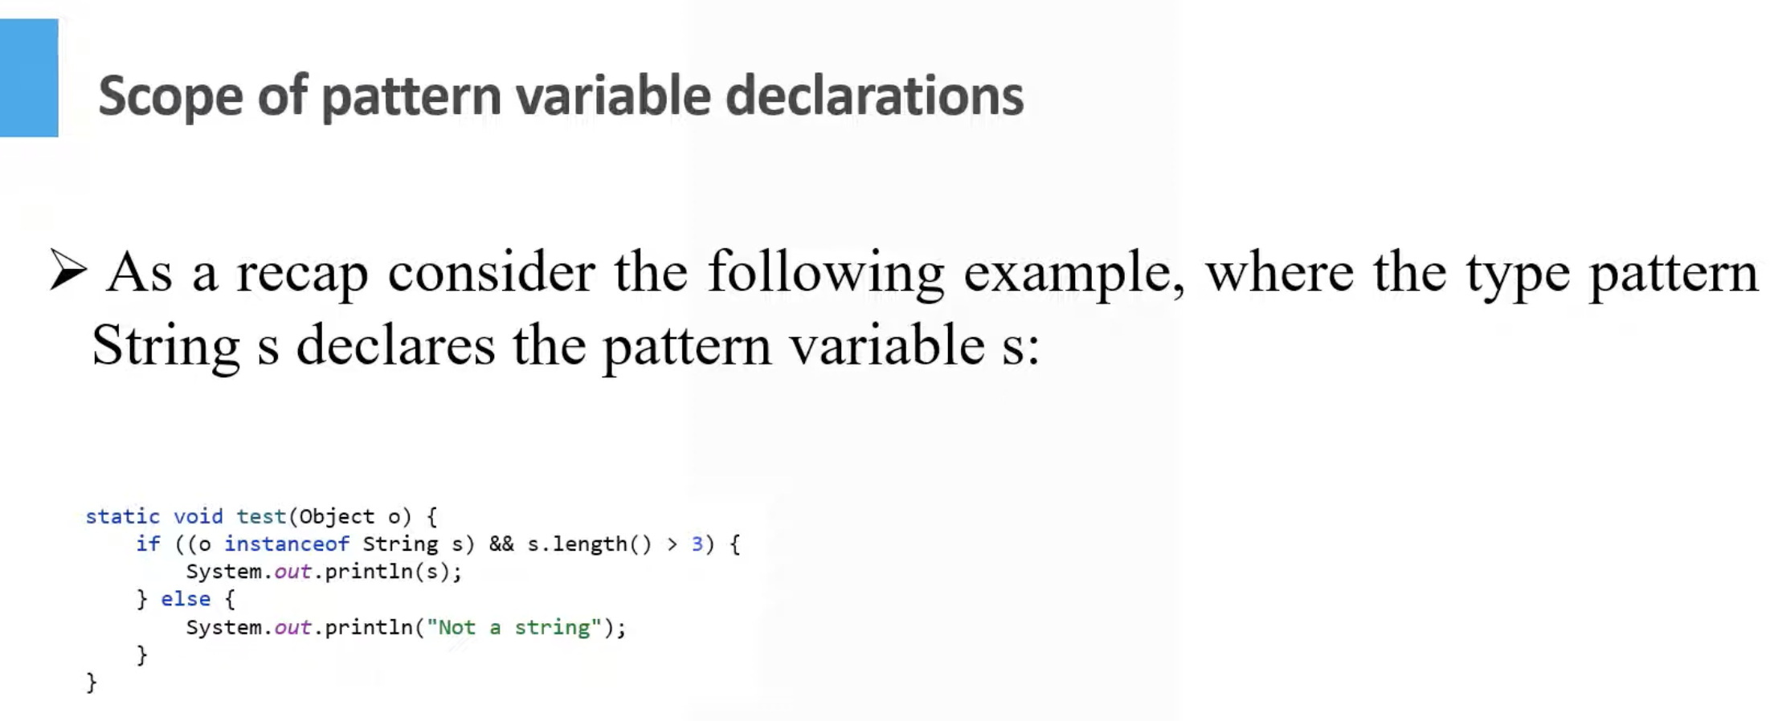

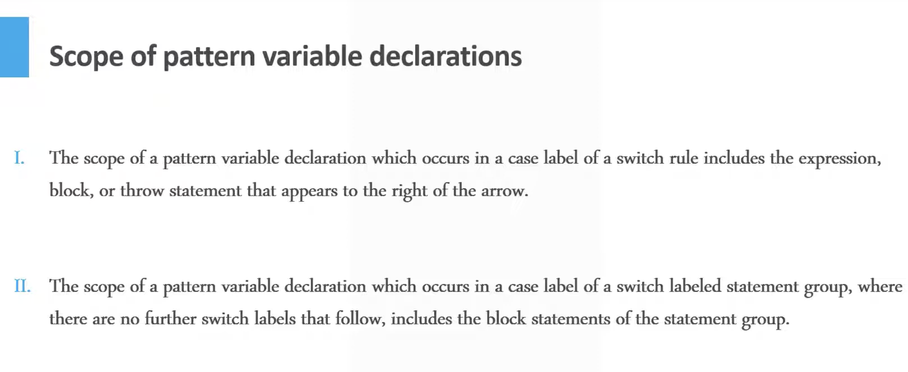

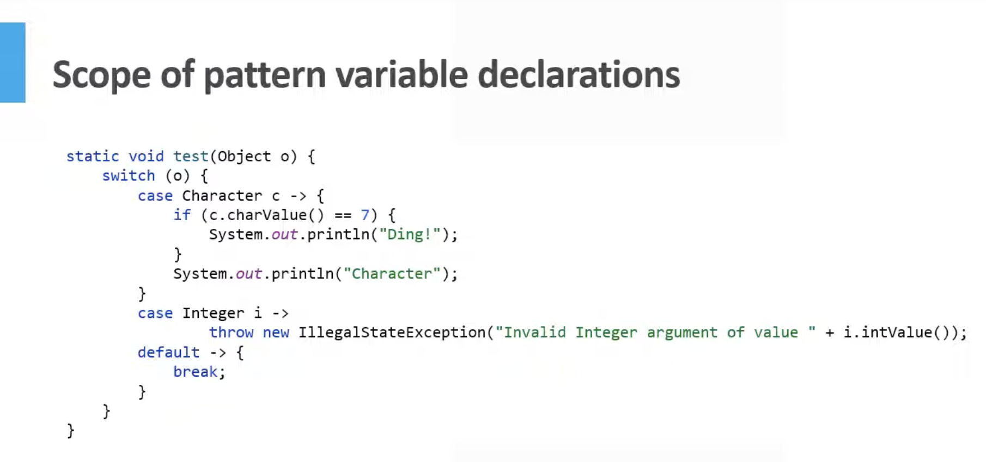

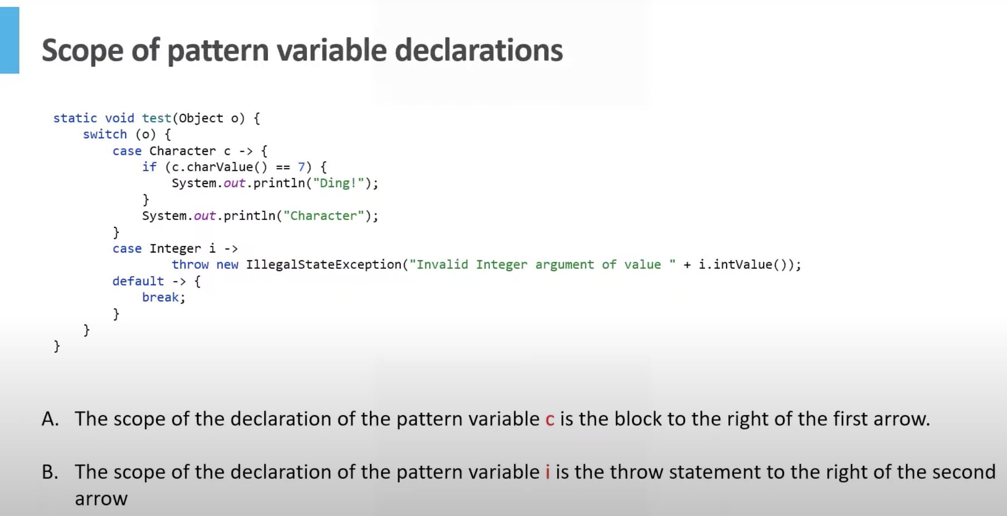

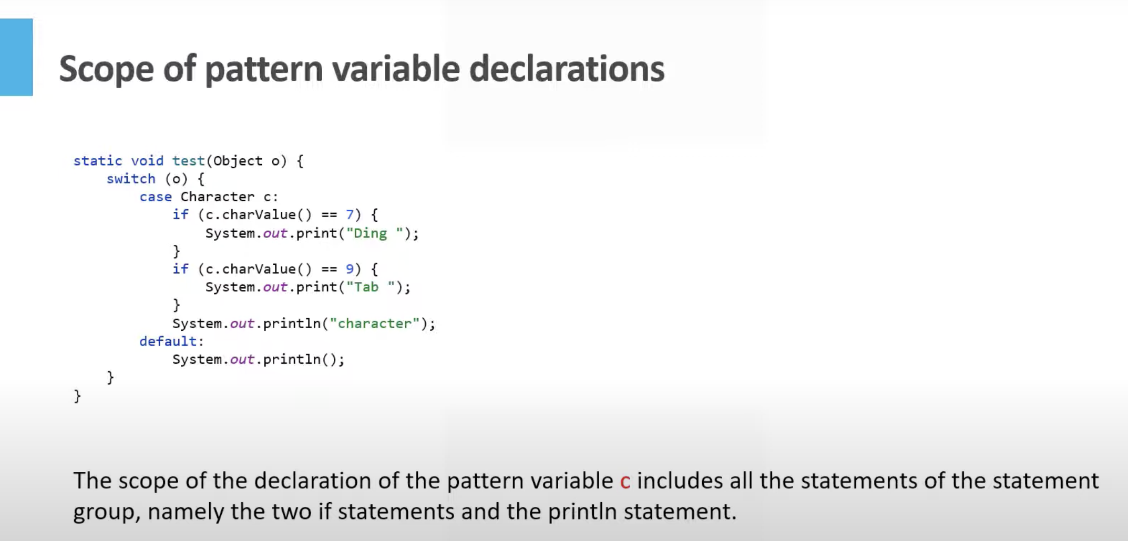

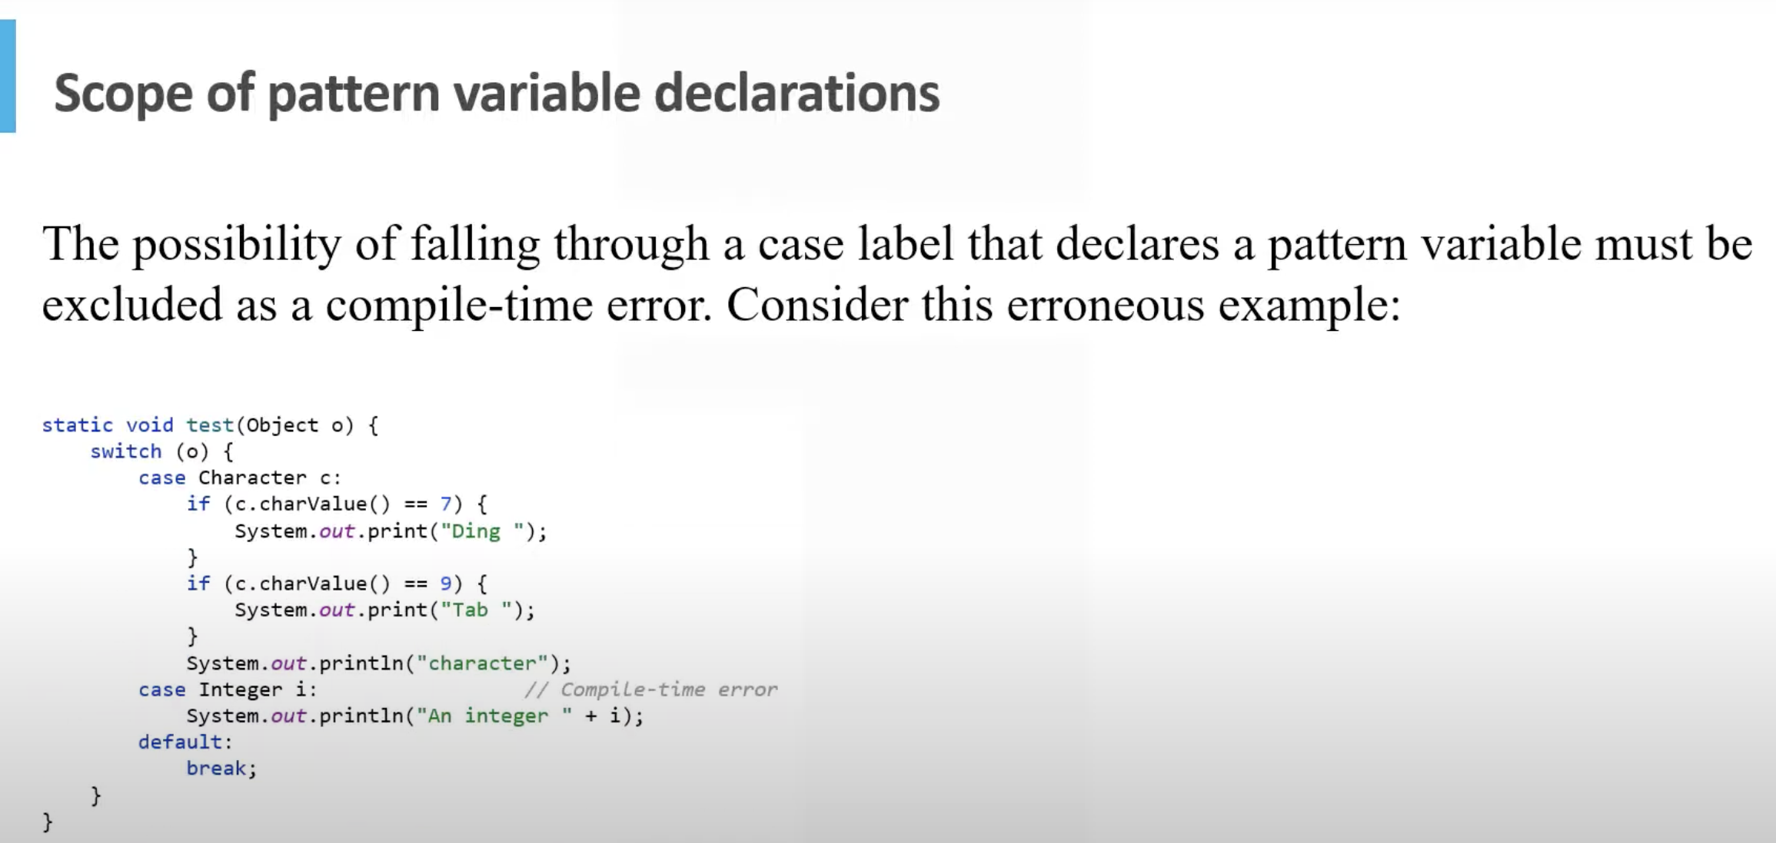

Here I may not be intailized in above screenshot.

SO

Case Character c :

Case Integer I:

Case Character c ->

Case Integer I –>

Is not allowed,as only one of them woud have been initaizzwd

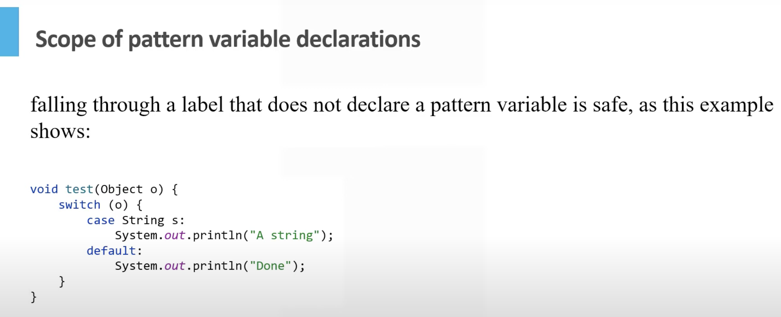



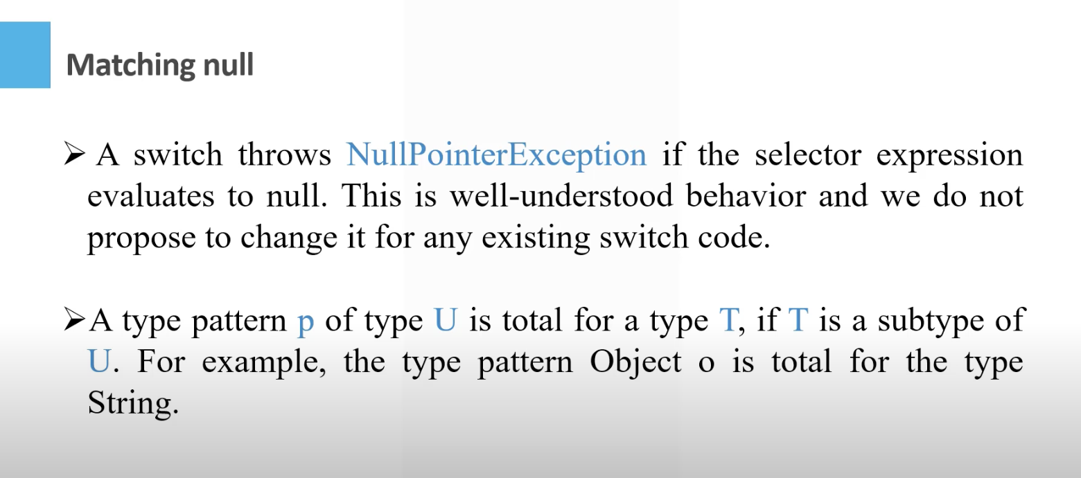

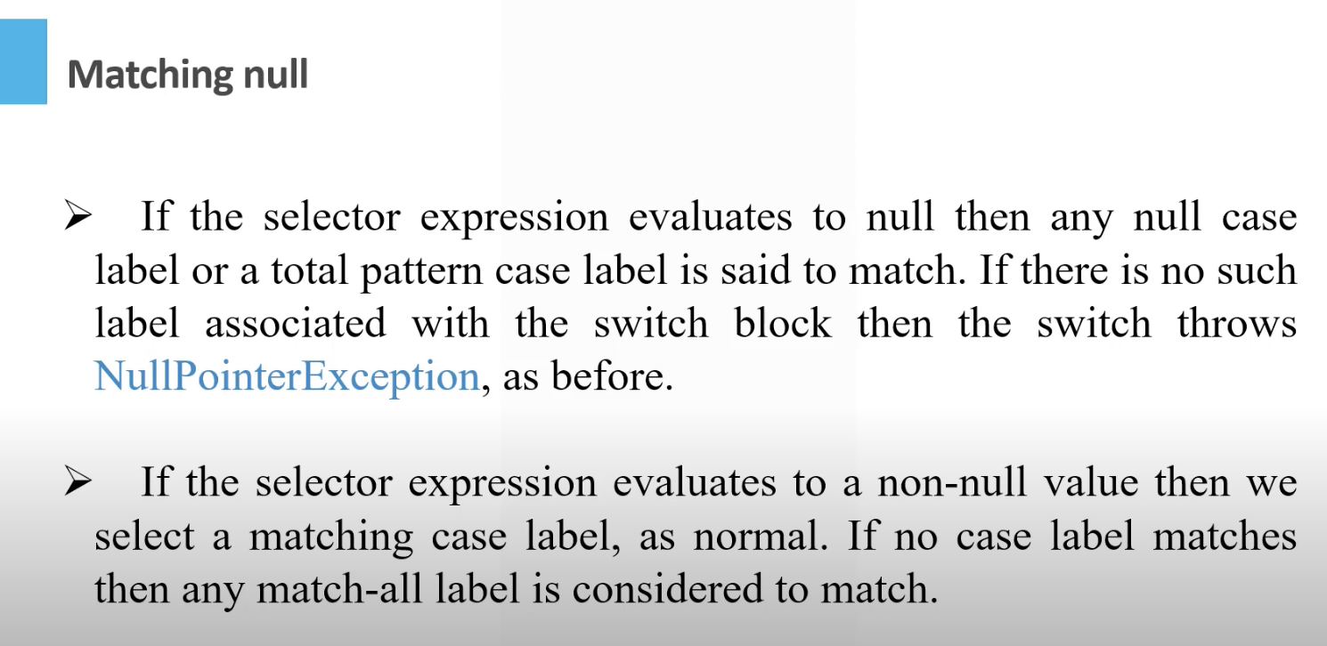

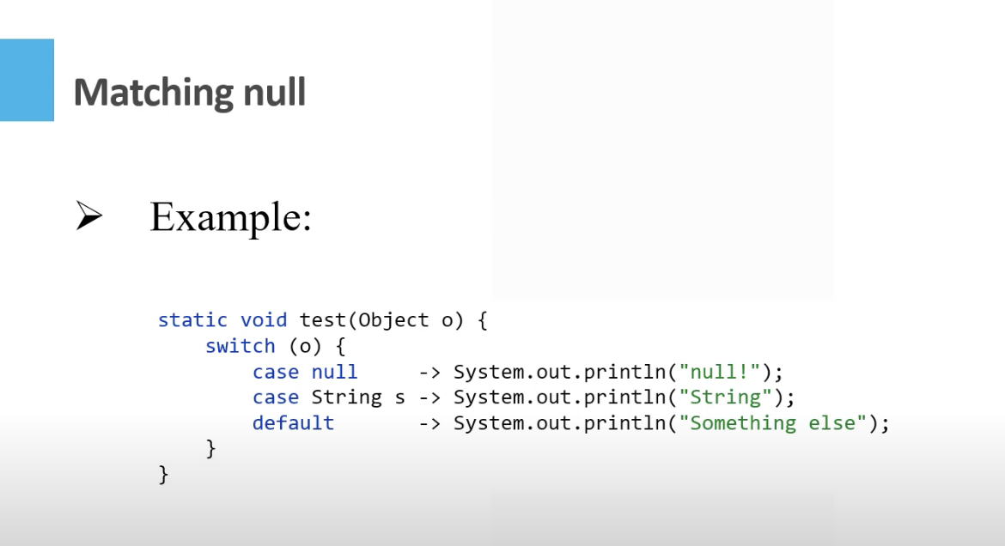

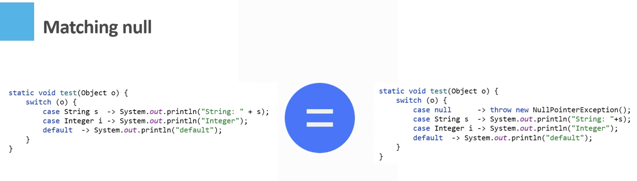



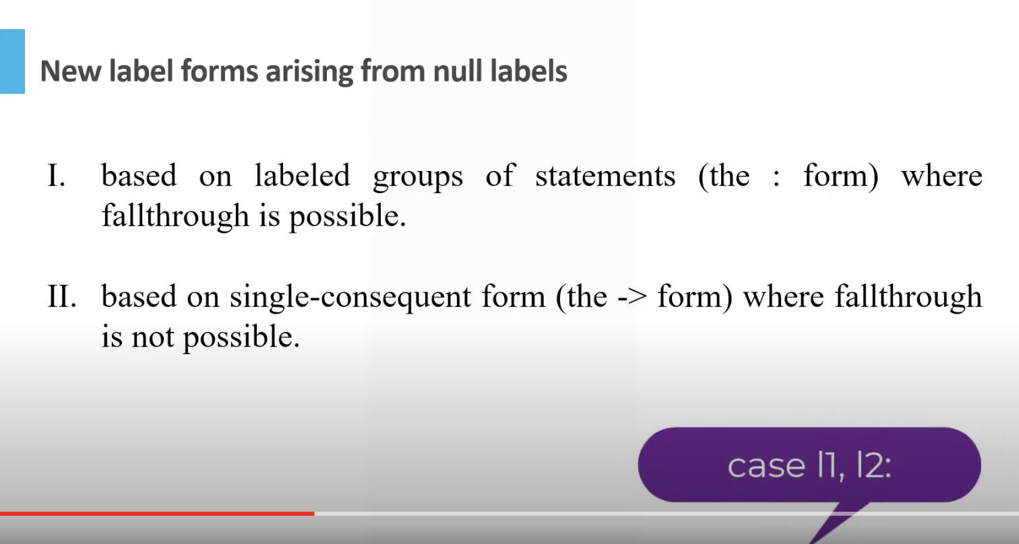

Prior supports case 1, case 2 :, later supports case 1,2:

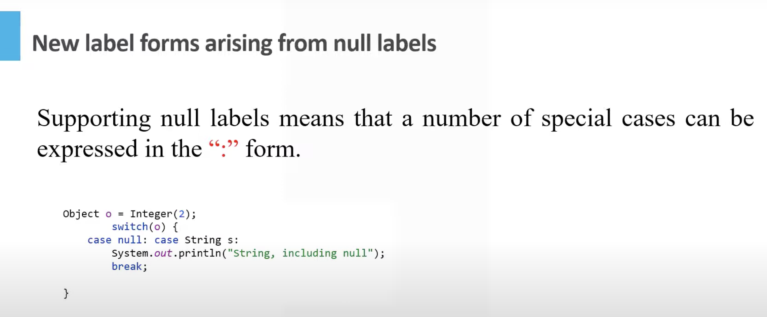

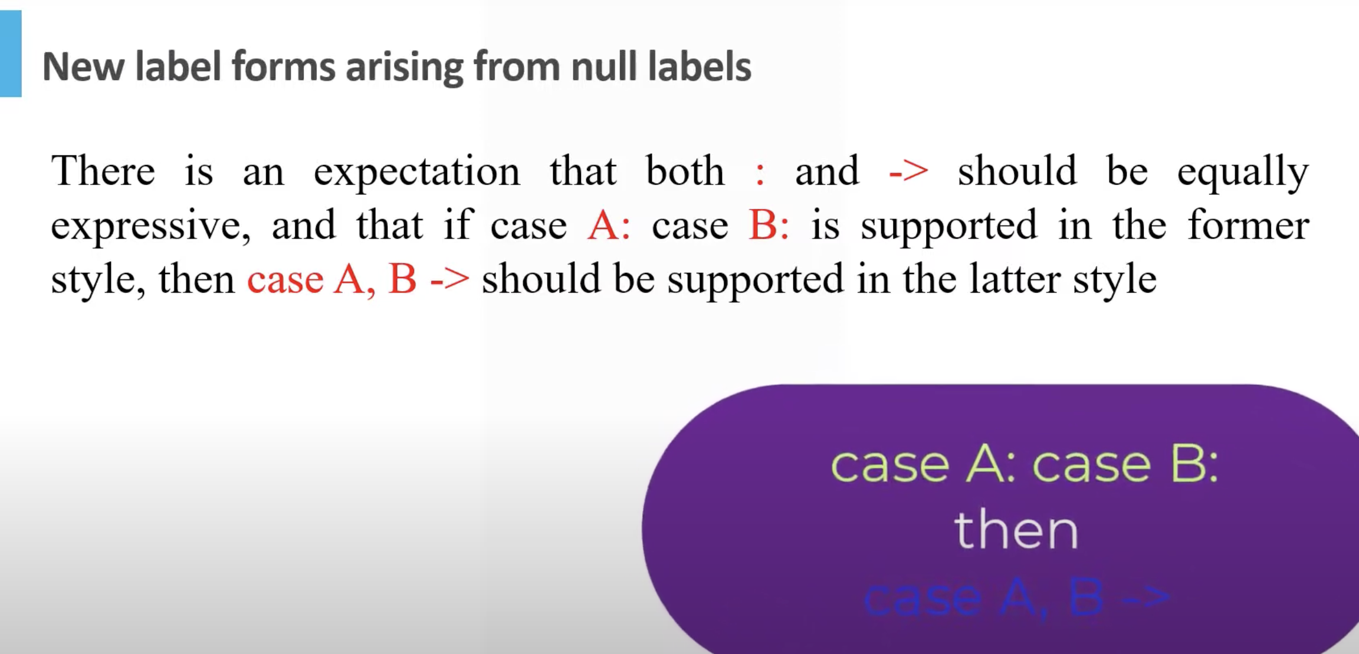

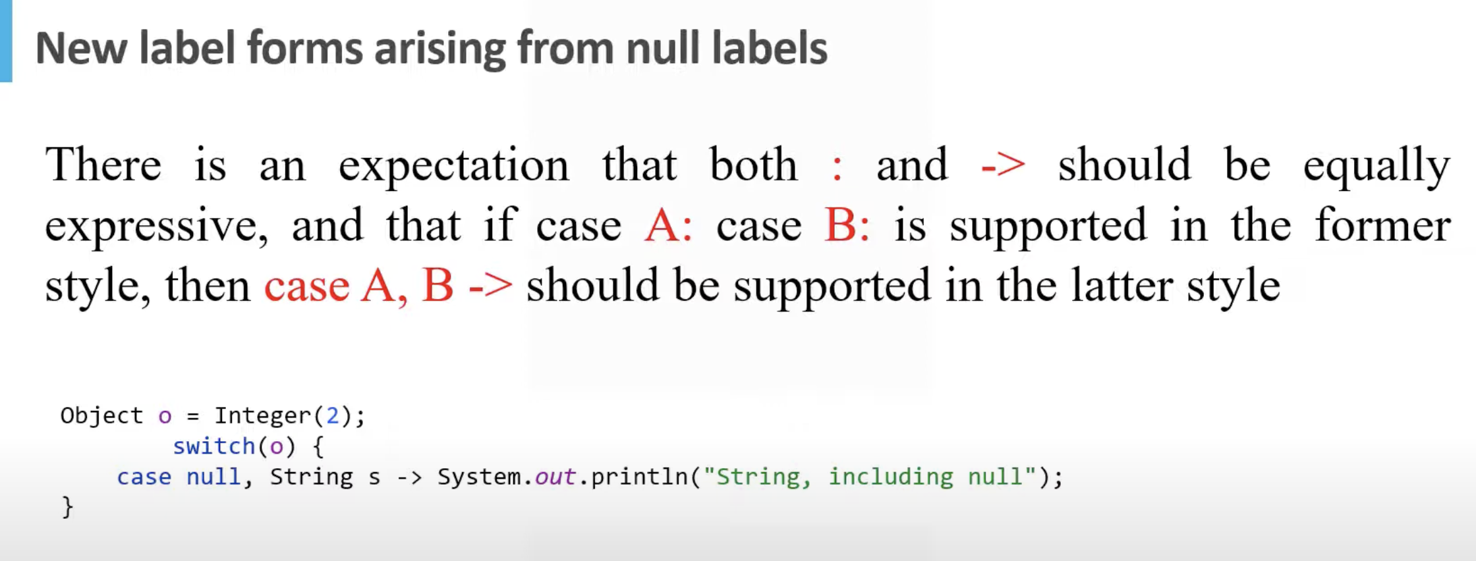

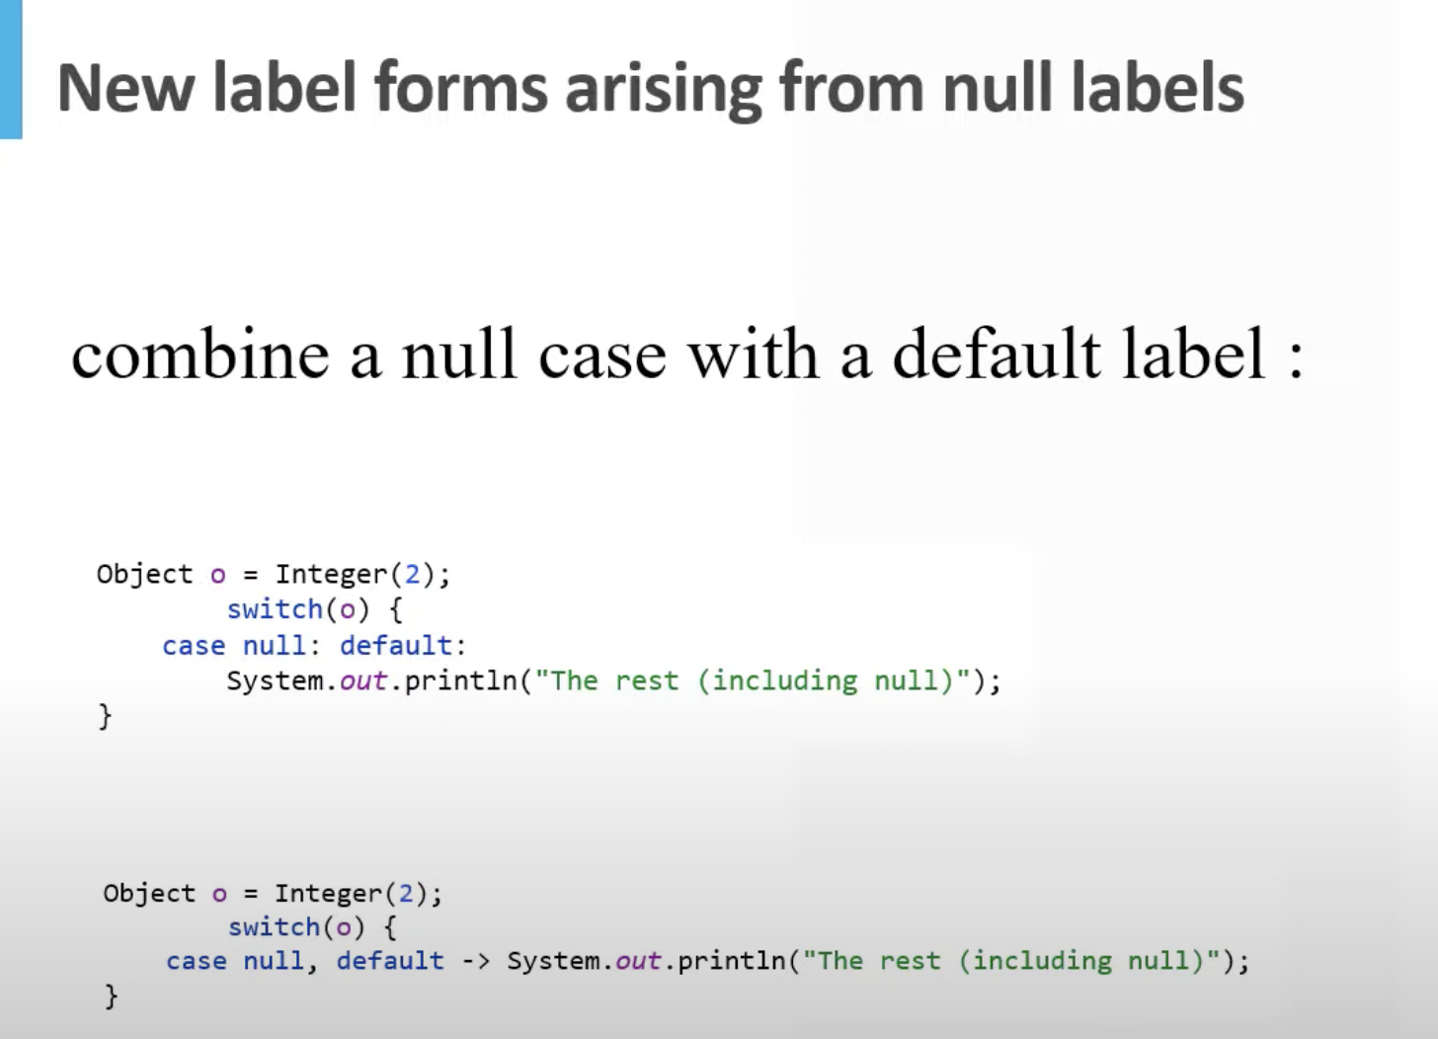

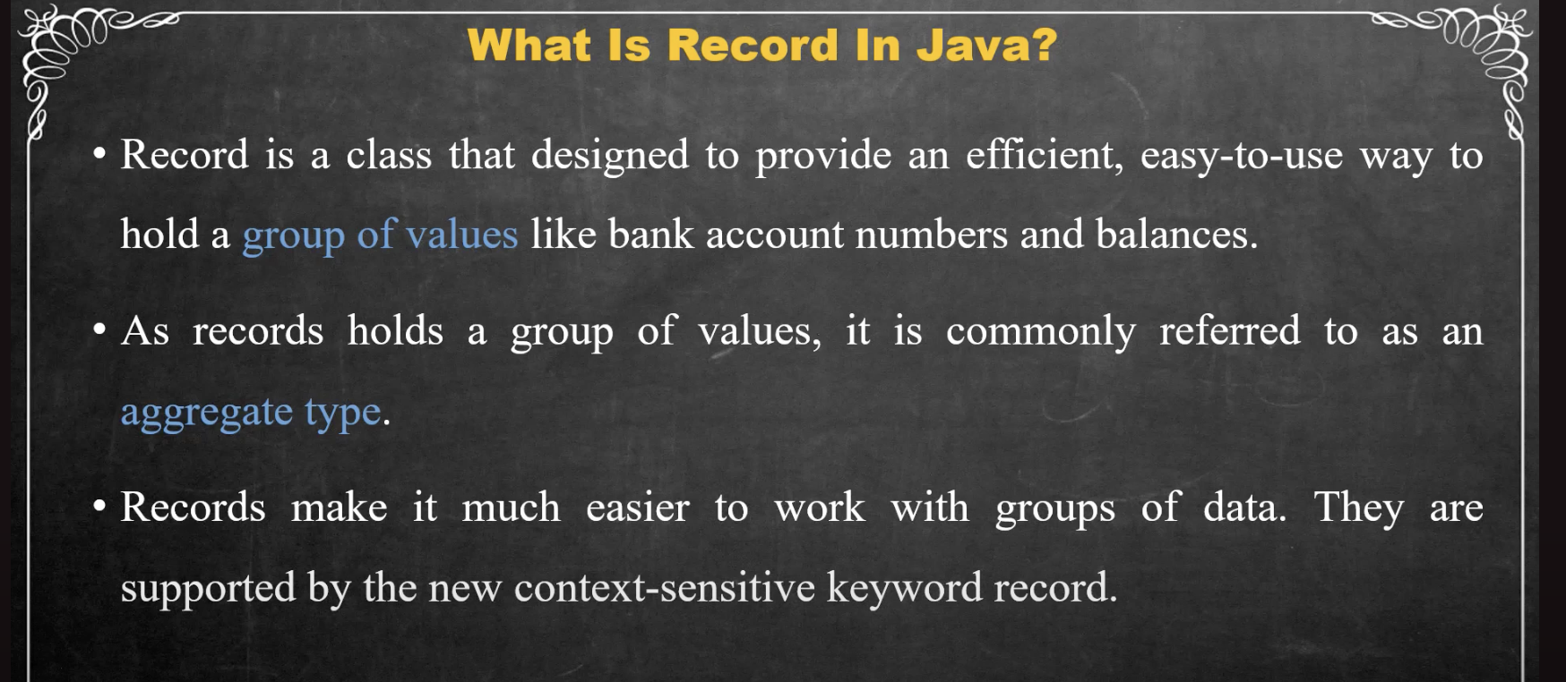

Public record employee(String name , int Id){

//body is optional

}

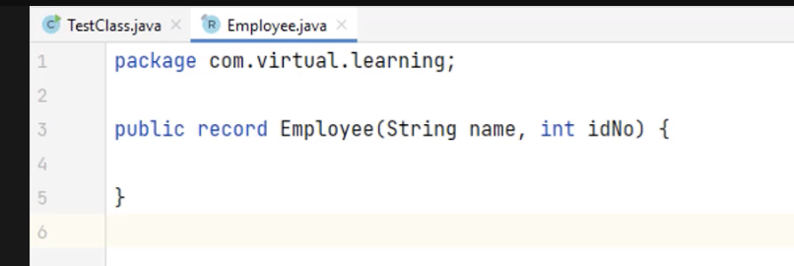

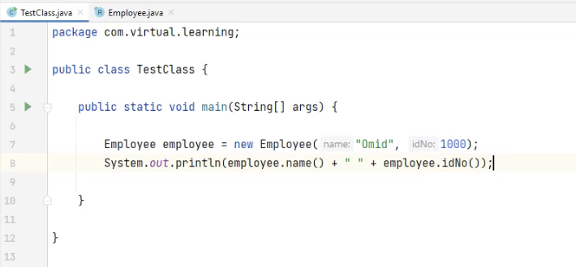

The data is held in prvate fields and getter methods are provided , so its immutable , so once its created you cannot change the record. But if record holds a reference to some object you can change that object but you cannot change to what object the reference in the record refers.

Please notice record cannot inherit a class, but it implicitly extends abstract record class and hecnec canot extend oter classes as java doesn’t support muliptle inheritance

* We cannot declare instance variables or instance initializers in a record class
* We cannot declare [***native***](https://www.baeldung.com/java-native) methods in a record class
* Moreover, we can add instance methods as well as static fields and methods to the record body:
* **public** **record** **USCitizen**(String firstName, String lastName, String address) {
* **static** **int** countryCode;
* // static initializer
* **static** {
* countryCode = 1;
* }
* **public** **static** **int** **getCountryCode**() {
* **return** countryCode;
* }
* **public** String **getFullName**() {
* **return** firstName + " " + lastName;
* }
* }
* The above record contains a static field, a static method, and an instance method.

IT can implement one or more interfaces with exception of equals, you cannot use the name of methods deifned by object as name for a record components. It can contain static and record can be a generic.

You can provide implementation for canoncaol contructor for a number of reason. There are two types of contructor, canonical and non canonical constructor. In canonical you can write explicitly or do a compact record constructor

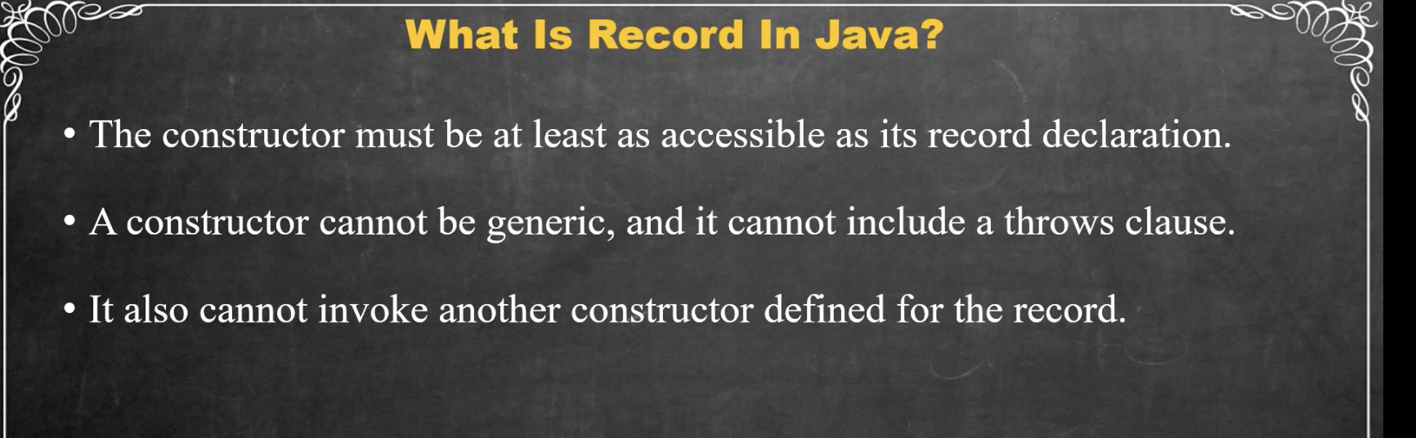

//way 1: writing expliclty anonocal contructor  
// public Employee(String naem , int id){  
// this.naem = naem;  
// this.id = 1000 +id;  
//  
// }  
  
 //way 2:Compact contructor  
 public Employee{  
 //you can alter one or movre values assigend  
 naem = naem.toLowerCase();

Non canocail constructor calls Canoncail sonctucotr

}

Non canocail constructor calls Canoncail- use case when you want values to be defaulted to osme value

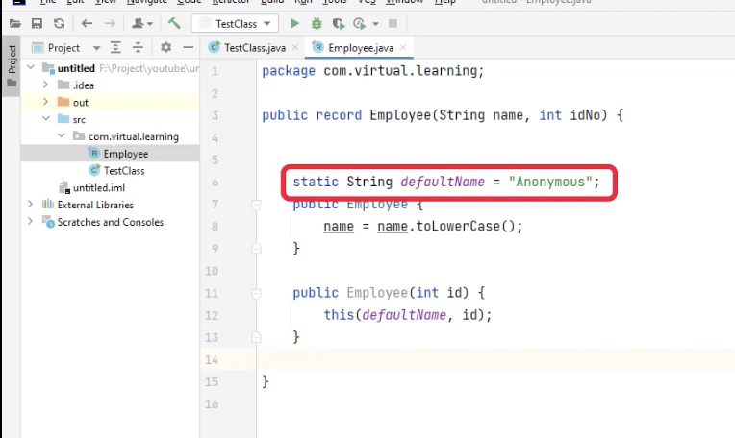

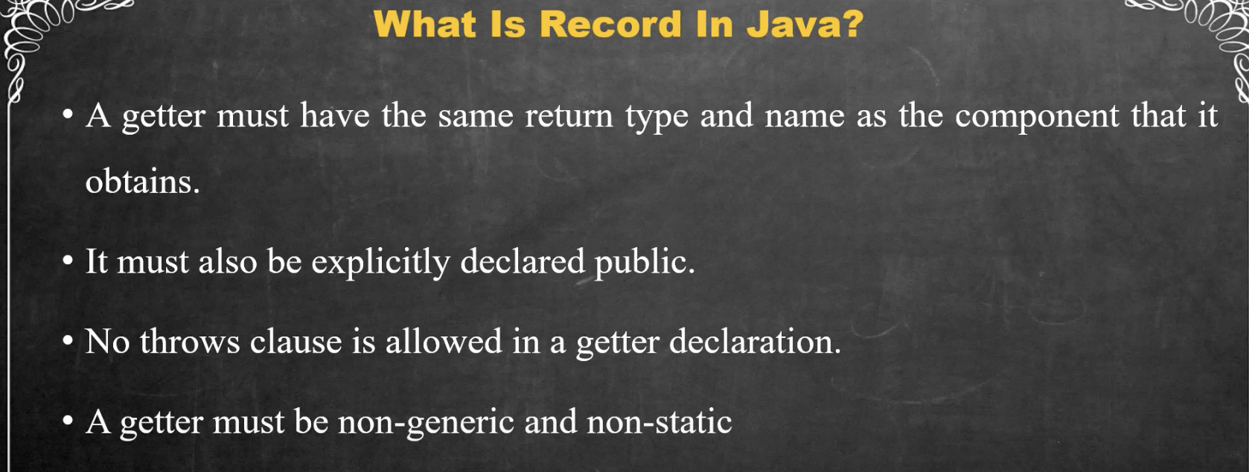

If you just need lastname fdont use a getter as it would change the record so. Use a method in record to get last name

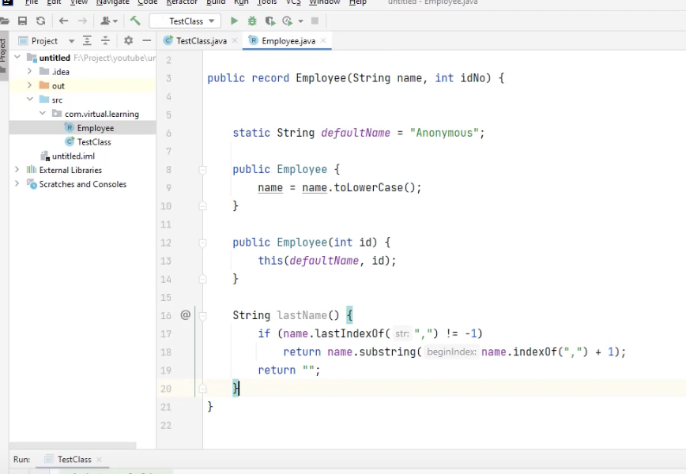

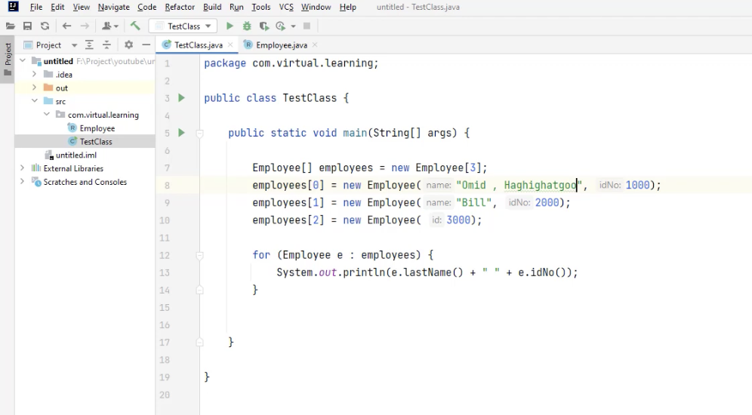

If there is no last name then constructor would throe error , to avoid it we van add exception

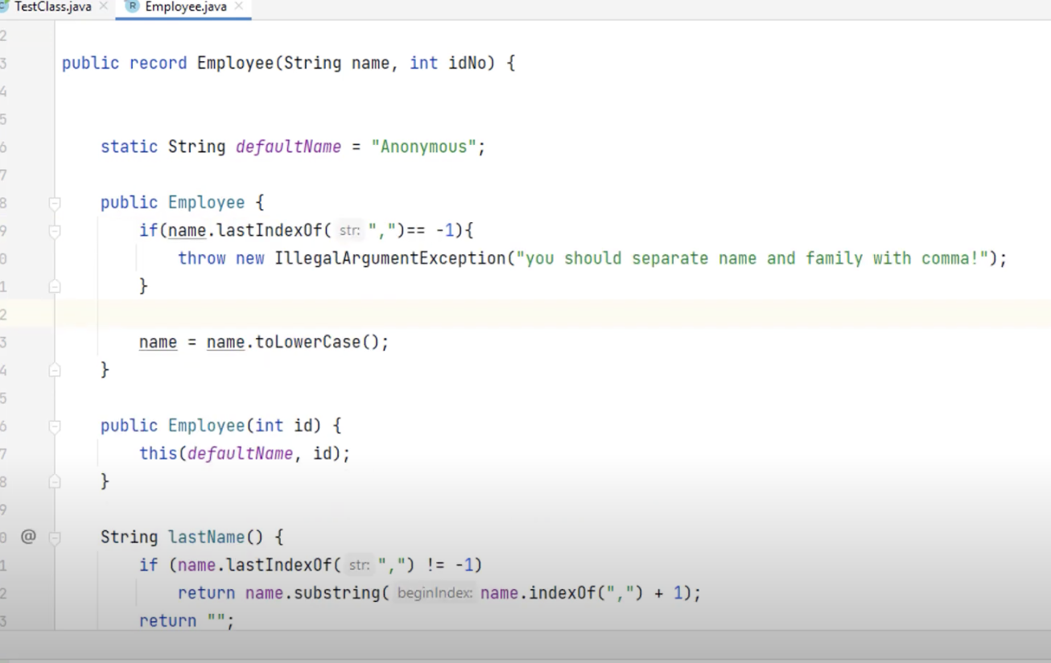

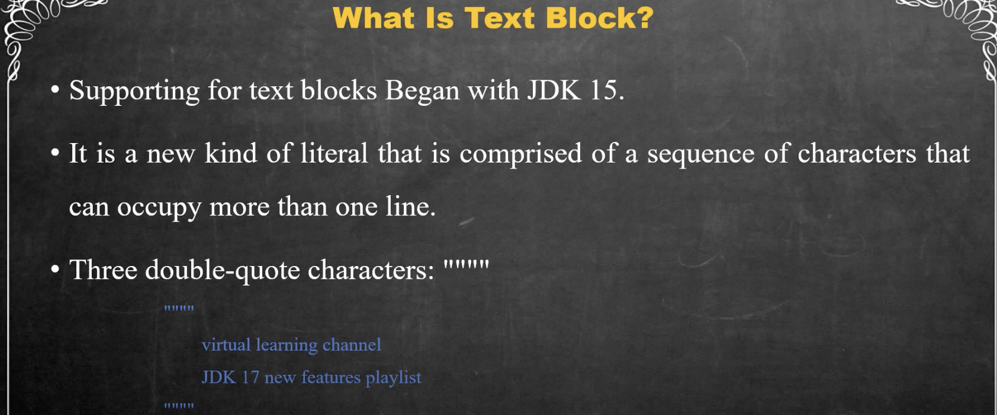

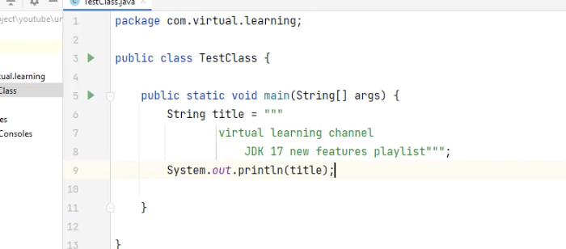

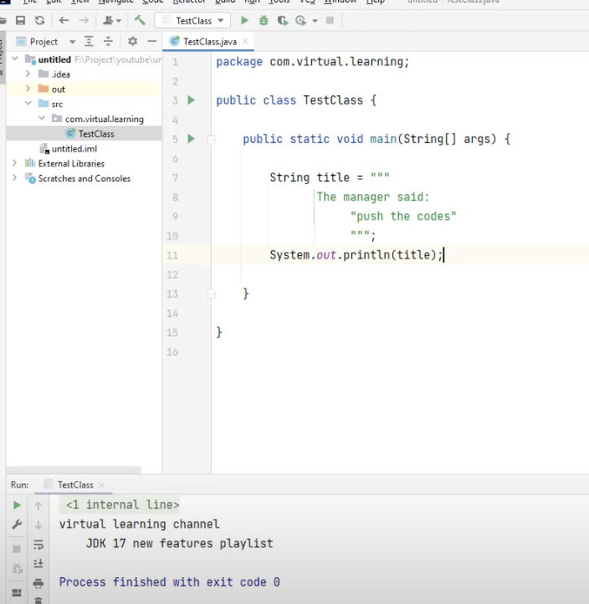

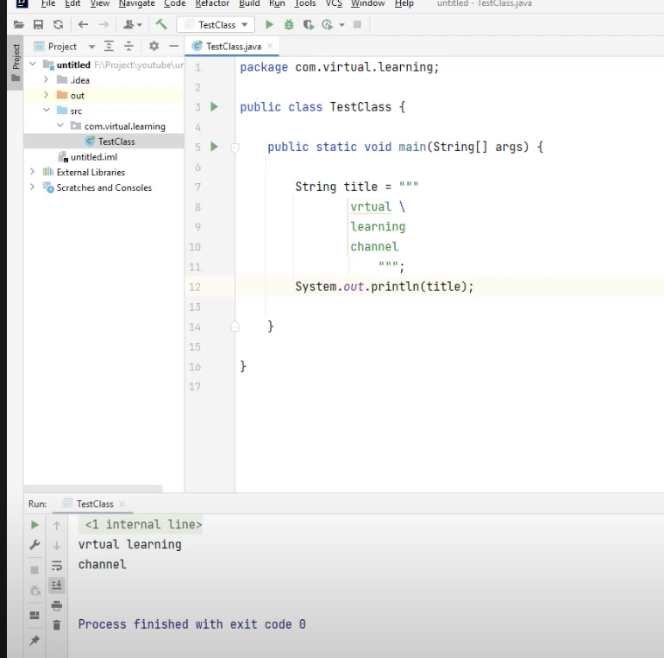

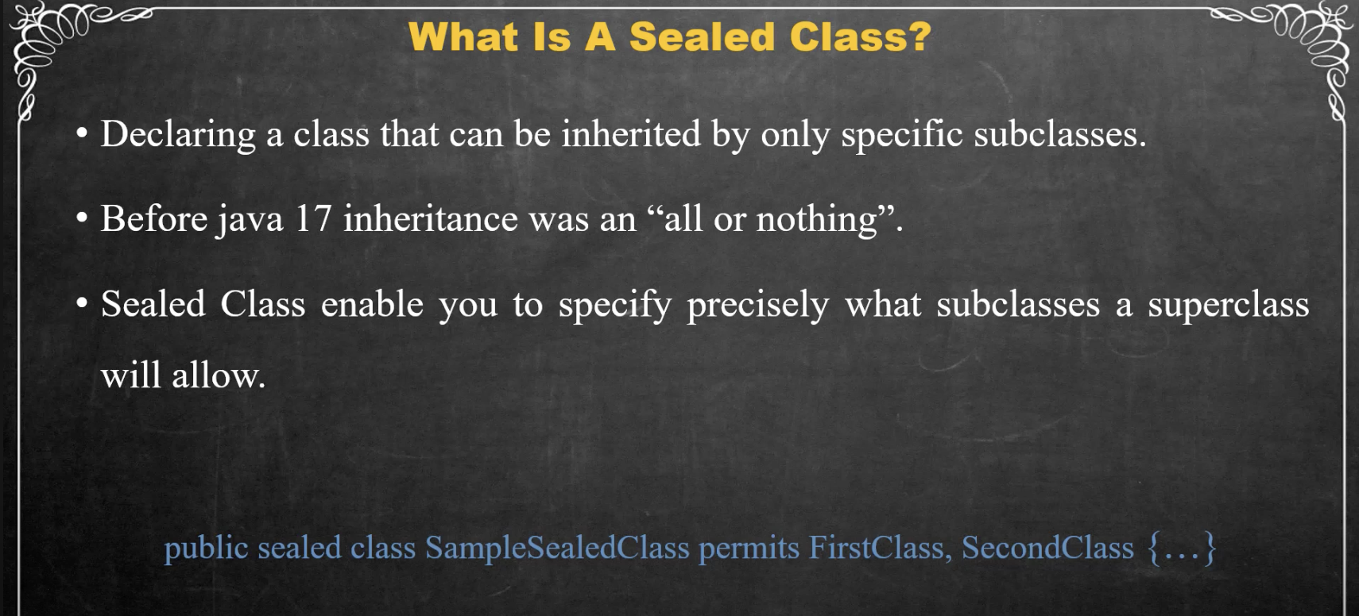

Requiremetn **A sealed class imposes three important constraints on its permitted subclasses:**

* All permitted subclasses must belong to the same module as the sealed class.
* Every permitted subclass must explicitly extend the sealed class.
* Every permitted subclass must define a modifier: final, sealed, or non-sealed.